Please

- use my version for XHU4
- Re-do the run with met+gas ASAP
- Read through 3 times before XHU4 submission.

WRF/Chem-MADRID: Incorporation of an Improved Aerosol Module and Its Application to the TexAQS2000 Episode
Xiao-Ming Hu¹, Yang Zhang¹*, Jerome. D. Fast², and Georg A. Grell^{3,4}
¹North Carolina State University, Raleigh, NC
²Pacific Northwest National Laboratory, Richland, WA
³NOAA- Earth Systems Research Laboratory, Boulder, CO
⁴CIRES, University of Colorado, Boulder, CO

ABSTRACT
Gas/particle mass transfer process plays an important role in determining aerosol mass concentrations and shaping aerosol size distribution. Its treatments in three dimensional (3-D) Air Quality Models (AQMs), however, are largely uncertain. In this paper the Model of Aerosol Dynamics, Reaction, Ionization and Dissolution (MADRID) with the improved gas/particle mass transfer approaches has been incorporated into the Weather Research and Forecast/Chemistry Model (WRF/Chem). The resulted system is referred to as WRF/Chem-MADRID.
WRF/Chem-MADRID with three gas/particle mass transfer approaches (i.e., bulk equilibrium (EQUI), hybrid (HYBR), and kinetic (KINE)) has been evaluated with a 5-day episode from the 2000 Texas Air Quality Study (TexAQS2000). WRF/Chem-MADRID demonstrates reasonably good skills in simulating surface/aloft meteorological parameters and surface chemical concentrations, but performs poorly for trospheric O3 residual and aerosol optical depth predictions, due largely to the uncertainties of the boundary conditions used for O3 and PM2.5 in upper layers. WRF/Chem-MADRID (EQUI), (HYBR), and (KINE) overpredict PM_{2.5} by 31.5%, 31.0%, and 30.8%, respectively. Major differences in simulation results by three gas/particle mass transfer approaches occur over coastal areas, where WRF/Chem-MADRID (EQUI) predicts higher PM_{2.5} concentrations than those predicted by WRF/Chem-MADRID (HYBR) and (KINE) due to improperly redistributing condensed nitrate from the chloride depletion process to fine mode. In comparison, WRF/Chem-MADRID (KINE) and (HYBR) correctly predicts chloride depletion process for coarse PM modes.
Keywords: TexAQS2000; WRF/chem-MADRID; gas/particle mass transfer; online air quality model; model evaluation

1 Introduction
Gas/particle mass transfer process plays the most important role among aerosol dynamic processes for determining aerosol mass concentrations (Wexler et al., 1994; Lurmann et al., 1997; Sun and Wexler, 1998; Russell and Dennis, 2000; Seinfeld, 2004). It also affects the deposition rates of trace species, which are highly dependent on the phase state of the species. However, significant uncertainties are associated with its treatment in three dimensional (3-D) Air Quality Models (AQMs) (Wexler and Seinfeld, 1990; Koo et al., 2003; Hu et al., 2008a). Three main approaches (i.e., equilibrium, kinetic (or dynamic), and hybrid) have been used to simulate gas/particle mass transfer in AQMs (Zhang et al. (1999, 2004)). Hu et al. (2008a) tested three gas/particle mass transfer approaches in the Model of Aerosol Dynamics, Reaction, Ionization and Dissolution (MADRID) of Zhang et al. (2004). They found that the bulk equilibrium and hybrid approaches fail to predict the distribution of semivolatile species (e.g., ammonium, chloride, and nitrate) under certain conditions (e.g., when the concentrations of reactive coarse particles are high); the kinetic approach predicts the most accurate solutions. The theoretical formulation for kinetic gas/particle mass transfer calculation has been well established, its numerical solution, however, remains challenging (Zaveri et al., 2008). Computationally efficient yet accurate kinetic approaches have been developed in several recent studies (e.g., Jacobson, 2005; Zhang and Wexler, 2006; Hu et al., 2008a; Zaveri et al., 2008). For example, by coupling the noniterative, unconditionally-stable analytical predictor of condensation (APC) of Jacobson (1999, 2005) with the thermodynamic model ISORROPIA (version 1.7) of Nenes et al. (1998, 1999) to solve gas/particle mass transfer explicitly, the efficiency of kinetic and hybrid approaches was improved, making their 3-D applications feasible (Hu et al., 2008b). In this work the improved MADRID with three gas/particle mass transfer approaches (i.e., bulk equilibrium, hybrid/APC and kinetic/APC) of Hu et al. (2008a) has been incorporated into the Weather Research and Forecasting model with chemistry (WRF/Chem) (Grell et al., 2005; Fast et al., 2006) and evaluated in a 3-D application.
Different from most 3-D AQMs developed so far, WRF/Chem is an online-coupled meteorology-air quality model that is able to simulate meteorology-chemistry-aerosol-cloud-radiation feedbacks. WRF/Chem version 2.2 consists of three gas-phase mechanisms (i.e., Regional Acid Deposition Model, version 2 (RADM2) (Stockwell et al., 1990), the Regional Atmospheric Chemistry Mechanism (RACM) (Stockwell et al., 1997), and Carbon-Bond Mechanism version Z (CBM-Z) (Zaveri and Peters, 1999)) and two aerosol modules (i.e., the Modal Aerosol Dynamics Model for Europe (MADE) (Ackermann et al., 1998) with the secondary organic aerosol model (SORGAM) (Schell et al., 2001) (referred to as MADE/SORGAM) and the Model for Simulating Aerosol Interactions and Chemistry (MOSAIC) (Zaveri et al., 2008)). WRF/Chem with RADM2 and MADE/SORGAM was first applied for the summer 2002 NEAQS filed study and demonstrated a skill in forecasting O₃ that is statistically better than that of MM5/Chem (Grell et al., 2005). WRF/Chem with RADM2 or RADM2-MADE/SORGAM has also been used for the ensemble forecast of O₃ (McKeen et al., 2005) and PM_{2.5} (McKeen et al., 2007) and for the evaluation of the impacts of emission reductions on O₃ concentrations in the eastern U.S. (Frost et al., 2006). WRF/Chem with CBM-Z and MOSAIC has been applied to a 5-day episode from the 2000 Texas Air Quality Study (TexAQS) (referred to as TexAQS2000) and demonstrated a good skill in reproducing. In this study, the improved MADRID of Hu et al. (2008a) was incorporated into WRF/Chem (referred to as WRF/Chem-MADRID) and evaluated using the same TexAQS2000 episode of Fast et al. (2006) over the Houston-Galveston, Texas (TX) area. Our objectives are to improve WRF/Chem’s capabilities in simulating aerosols, evaluate WRF/Chem-MADRID using observational data from the TeXAQS2000, and examine the sensitivity of simulated aerosol predictions to different gas/particle mass transfer approaches.
2 Description of WRF/Chem-MADRID, Setup, and Evaluation Protocol

The original MADRID codes, mostly written in FORTRAN 77 fixed format, were first converted to FORTRAN 90 free format required by WRF/Chem, then incorporated into WRF/Chem version 2.2 and coupled with CBM-Z. Since MADRID also uses a sectional size representation that is similar to that used in MOSAIC, MADRID was incorporated into WRF/Chem using a similar interface as that of MOSAIC to map the global variables of WRF/Chem to local variables used in MADRID. Since CBM-Z/MOSIAC implemented in WRF/Chem version 2.2 does not treat secondary organic aerosols (SOA), the SOA treatments in MADRID are not activated in this work. Table 1 compares the three aerosol modules and their corresponding gas phase mechanisms in the NSCU’s version of WRF/Chem v2.2. Please describe why MADRID was implemented into WRF/Chem as an alternative to MOSAIC and MADE/SORGAM and what the major differences between MADRID and the two default aerosol modules are (follow the order of mechanisms shown in Table 1 to describe similarities and differences). WRF/Chem-MADRID has been applied to the 2000 TexAQS episode (Zhang et al., 2005; Hu and Zhang, 2006; Hu et al., 2006), the 2001 Continental U.S. episode (Hu and Zhang, 2007; Pan et al., 2008a, b) and the 2004 NEAQS episode (Hu et al., 2007; 2008b).
Houston, TX is the fourth most populous city in the U.S. with a population of four millions. Traffic and other anthropogenic activities result in high emission rates of NO_{x} and volatile organic compounds (VOCs) in this area. Depending on the wind direction, the emissions of isoprene and monoterpene from the forested regions in the northeast of Houston also contribute to the total VOC emissions in the Houston area. Exceedance of an annual PM_{2.5} National Ambient Air Quality Standard (NAAQS) of 15 µg m⁻³ has been a concern of Houston’s environmental issue (Russell et al., 2004). Direct emissions in this area contribute to approximately 40-50% of PM_{2.5} while secondary sources account for 50-60% of PM_{2.5} with inorganic species dominated the secondary PM (Russell and Allen, 2004; Pavlovic et al., 2006; Allen and Fraser, 2006). The southeastern TX is affected by sea-salt emissions from the Gulf of Mexico as well as the anthropogenic emissions. Certain gas/particle mass transfer approaches may fail to predict the distribution of semi-volatile species for areas where anthropogenic emissions are mixed with sea-salt emission (Hu et al., 2008a). The high percentage of secondary PM and the mixing of sea-salt and anthropogenic emissions make the TexAQS2000 episode an ideal testbed to test the gas/particle mass transfer approaches in WRF/Chem-MADRID. As compare with other large cities in the U.S., another distinct characteristics of Houston is the numerous petrochemical industries in its surrounding area. 40% of the world's production capacity of low molecular weight alkenes is estimated to be produced in the Houston-Galveston area (Daum et al., 2004). The highest density of petrochemical industries is surrounding the Houston Ship Channel. Also the nitrogen oxides emitted from ships is also significant (Kasibhatla et al., 2000). The O₃ mixing ratios in Houston often exceed the 1-h National Ambient Air Quality Standard (NAAQS) of 120 ppb (Daum et al., 2003). Under favorable meteorology conditions, the O₃ formation in Houston is rather rapid and some high O₃ events are observed even when background O₃ mixing ratio is modest (Daum et al., 2004), making the O₃ problem in Houston quite unique.
In August and September of 2000, the largest air quality study ever done for this area (i.e., the TexAQS2000) was conducted to improve the understanding of the formation and transport of the pollutants such as (O₃), particulate matter with aerodynamic diameters equal to or less than 2.5 μm (PM_{2.5}) along the Gulf Coast of the southeastern TX. Intensive measurements of gaseous, particulate, and hazardous air pollutants were made at approximately 20 ground stations, located throughout the eastern half of TX. The characteristics of air pollutants have been examined through both field (e.g., Kleinman et al., 2002, 2005; Ryerson et al., 2003; Wert et al., 2003; Daum et al., 2003; Karl et al., 2003; Russell et al., 2004; Banta et al., 2005; Murphy and Allen, 2005; Allen and Fraser, 2006; Webster et al., 2007) and modeling studies (e.g., Tanaka et al., 2000, 2003; Chang et al., 2002; Jiang and Fast, 2004; Darby, 2005; Nam et al., 2006; Chang and Allen, 2006; F. Zhang et al., 2007; Misenis et al., 2008).
In this study, a 5-day (1200 GMT Aug. 28 – 0600 GMT Sept. 2) episode from the TexAQS2000 is used as an initial testbed for the evaluation of WRF/Chem-MADRID. There are several reasons for selecting this 5-day period. First, more than 20 1-h O₃ exceedances were observed during this period in the Houston-Galveston-Brazoria area, among which 6 of them exceeded 150 ppb (http://www.tceq.state.tx.us/cgi-bin/compliance/monops/peak_monthly.pl). Second, sea breezes were observed during Aug 29-31, 2000, which is the typical meteorological circumstance associated with the high O₃ events in the Houston area (Banta et al., 2005; Darby, 2005).
Please reorganize the above three para to present materials in a logic way, the current order with testbed, emission, PM2.5, emission, O3, then testbed again is very confusing.
Two para will be sufficient. Please start with population/emission/meteorological characteristics, followed by O3 problems, then PM2.5 problems (first para.), Please also add meteorological characteristics over this region and describe how can it make pollution worse.
In 2nd para, please start with measurements, modeling testbed, and justification for testbed selection.

WRF/Chem-MADRID simulations are conducted for a region of 1056 × 1056 km² with a 12-km horizontal grid spacing and 56 layers from surface to 100 mb. Model input data (i.e., Meteorological initial and lateral boundary and emissions) are based on Fast et al. (2006). Meteorological initial and lateral boundary conditions were obtained from the North American Regional Reanalysis (NARR) (Mesinger et al., 2006). The chemical initial and lateral boundary conditions are set horizontally homogeneous. The initial surface PM_{2.5} concentration is set to be 8 µg m⁻³ based on regional particulate measurements (Fast et al., 2006). The use of homogeneous initial and lateral boundary conditions for PM is justified because PM_{2.5} mass concentrations and composition are found to be generally spatially homogeneous throughout the southeastern TX on a seasonal average (Russell et al., 2004; Allen and Fraser, 2006). The emissions of gas phase species were provided by the Texas Commission on Environmental Quality (TCEQ). The particulate matter emission was obtained from the EPA’s 1999 National Emissions Inventory (NEI) version 3. Eight size sections over 0.0215 μm - 10 μm are used to represent the aerosol size distribution. Secondary organic aerosol (SOA) is not simulated for the reason stated previously. Although organic carbon (OC) makes up ~25-30% of total PM_{2.5,} primary emissions are its dominant source around the Houston area (Russell and Allen, 2004; Allen and Fraser, 2006). Neglecting SOA affects OC predictions, it, however, may not introduce large errors in the testing of gas/particle mass transfer approaches as most of OC exist in the PM_{2.5} size range (Russell et al., 2004). Major physics and chemistry options used are summarized in Table 2. Physics options used include the Goddard shortwave radiation scheme (Chou et al., 1998), the rapid and accurate radiative transfer model (RRTM) (Mlawer et al., 1997) for longwave radiation, the Yonsei University (YSU) planetary boundary layer (PBL) scheme (Hong et al., 2006), and the National Center for Environmental Prediction, Oregon State University, Air Force, and Hydrologic Research Lab’s (NOAH) land-surface scheme (Chen and Dudhia, 2001a, 2001b). Cloud microphysics module is turned off since there is no precipitation around Houston-Galveston area during this episode. Chemical options used CBMZ gas phase mechanism and MADRID aerosol module. Simulations are conducted with three different gas/particle mass transfer approaches, i.e., the bulk equilibrium, hybrid/analytical predictor of condensation (APC), and kinetic/APC approaches (referred to as WRF/Chem-MADRID (EQUI), (HYBR), and (KINE), respectively). All these simulations include aerosol direct feedback effects on meteorology through the modification of radiation and NO₂ photolysis, aerosol indirect effects on cloud formation and precipitation via serving as cloud condensation nuclei (CCN) are not simulated.
The observational data used for our model evaluation are summarized in Table 3. The meteorological variables and chemical conc. (surface and column) evaluated include temperature, relative humidity, wind speed, wind direction, CO, NO, NO₂, and O₃, Tropospheric Ozone Residual, PM_{2.5}, Aerosol optical depth, short wave radiation. A number of statistical metrics are used for model evaluation. These include: correlation coefficient (corr), mean bias (MB), mean absolute gross error (MAGE), root mean-square error (RMSE), mean normalized bias (MNB), mean normalized absolute error (MNAE), normalized mean bias (NMB), normalized mean error (NME), fractional bias (FB), fractional absolute error (FAE), normalized mean bias factor (NMBF), and normalized mean error factor (NMEF). Formulas for these metrics can be found in Seigneur et al. (2000), Yu et al. (2006), and Zhang et al. (2006). Temporal and spatial distributions, bar charts and vertical profiles are used for model evaluation. The simulated profiles are extracted along the flight tracks to compare with the flight observed profile. The flight observations below 4 km were made within half an hour in coastal areas (reference is needed here, Reply: tell from the data). Since model outputs once per hour, simulated profiles are extracted from the hourly model output that is closest to the observation time.
3 Model Evaluation
3.1 Meteorological Predictions
A few studies have indicated that the meteorological processes (e.g., sea breeze, low-level jets) play a vital role in O₃ events in Houston (Banta et al., 2005; Darby, 2005; F. Zhang et al., 2007). Without properly capturing these meteorological processes, it is unlikely for the model to accurately capture the O₃ events in terms of time of occurrence, location, and peak values. It is therefore important to evaluate meteorological predictions. Since the aerosol direct feedback effects) are simulated, different WRF/Chem-MADRID simulations (i.e., EQUI, HYBR, and KENI) will give different meteorology. Such feedbacks, however, are very similar, given similar aerosol predictions; therefore only the meteorological predictions from WRF/Chem-MADRID (EQUI) are evaluated.
Observed high O₃ events are associated with the occurrence of sea breezes over the Houston-Galveston area. Sea breeze circulations were clearly observed on Aug. 29 – 31, 2000 over this area (Banta et al., 2005; Daum et al., 2003). Daum et al. (2003) analyzed the sea breeze development on Aug. 29, 2000 (see Figure 3 in Daum et al., 2003). The corresponding simulated wind fields at 8, 10, 12, 16, and 18 central standard time (CST) on August 29 from WRF/Chem-MADRID are shown in Figure 1 (a)-(f). WRF/Chem-MADRID reproduced the observed sea breeze development sequence fairly well. The wind around Houston in the morning is westerly wind. A sea breeze develops around noon time. The front of the sea breeze reaches around Houston at 12 CST and a confluence line forms there, when the wind field is nearly stagnant around Houston. The see breeze continues in the afternoon and the see breeze front reaches more inland until 18 CST. The predicted wind fields at 11, 15, 17, and 19 CST on Aug. 30, 2000 are shown in Figure 2 ((g)-(j)), which can be compared with observed wind fields in Figure 4 of Banta et al. (2005). WRF/Chem-MADRID also reproduces the onset of see breeze on August 30, although the simulated see breeze is not as strong as that from observations.
Lack of penetration of the sea breeze is also reported from other model simulations (e.g., Angevine et al., 2006). The bias of the predicted sea breezes is shown to be partially caused by improper grid resolution (Colby, 2004). A horizontal grid resolution of 12 km used in the simulation of this study may be still too coarse to capture the local-scale atmospheric thermodynamics and dynamics around the Houston area, considering the rather inhomogeneous coastline nearby. Such a coarse resolution also can not well represent land use and land cover, which is critical to accurately predict the boundary layer meteorology (Grossman-Clarke et al., 2005). Discrepancies between the actual land use and that used in the model are suspected to contribute to the model biases reported in Bao et al. (2005). WRF/Chem uses the 24-category U.S. Geological Survey (USGS) land use and land cover dataset. Because the use of a coarse grid resolution, the division of land mask and land use do not match exactly with the coastal line, especially around Galveston Bay (e.g., some land areas are modeled as water area and vice versa) (Figure not shown). This mismatching will lower the model skill in capturing the see breezes, especially over Houston where the coastline is rather inhomogeneous.
Figure 2 shows the temporal variations of wind vectors at 10-m height at 31 (I did not see 31 sites, did you read through your paper?) observational sites (wind data from CAMS145 is not available). Please give full names of all 10 sites selected, and describe your criteria for selection (e.g., are they representative? If so, in what way? How many sites are urban, rural, and coastal? What are the geographical, emission and meteorological characteristics of those sites? Please describe general features of observed wind vectors at all sites and subsets of sites (e.g., urban, rural, coastal) before you talk about comparison. WRF/Chem-MADRID captures the diurnal variations of the wind fairly well at most sites. Please describe the sites with obs. sea breezes and whether model captures observations at those sites to provide a connection between wind vectors and previous para. on sea breezes. On the average, wind speed is overpredicted by 8.7%. Mean observed wind direction is south-southwestly while the simulated mean wind is biased to be more westly by 26 degrees (see Table 4) (is this true at most sites?). In addition to the overall statistics, the statistics for wind speed are calculated for nighttime and daytime separately. The performance of wind speed at night (with a correlation coefficient of 0.374, an MB of 0.941, and an NMB of 39.8%) is worse than that during daytime (with a correlation coefficient of 0.492, an MB of -0.374, and an NMB of -10.9%). The worse performance during nighttime may be due to the well-known model deficiency in accurately simulating nocturnal turbulent mixing near the surface, which is a common problem for all numerical weather prediction models (Bao et al., 2005). In our case, the YSU PBL scheme is used. In WRF/Chem version 2.2 YSU scheme is based on Hong et al. (2006), in which diffusivity for free atmosphere is used for stable PBL which may not be appropriate. Improved YSU stable model is available starting from WRFV3, in which stable PBL height is determined based on critical Richardson number (Hong and Kim, 2008; Kim et al., 2008).
Figures 3 and 4 show the temporal variations of T2 at 16 out of total 32 observational sites (i.e., Houston East (HOEA), Houston Aldine (HALC), Houston Bayland Park (BAYP), Houston Westhollow (SHWH), HRM-4 Sheldon Rd (H04H), LaPorte (H08H), Clinton (C35C), HRM-3 Haden Road (H03H), Galveston Airport (GALC), Houston Deer Park (DRPA), Conroe (CONR), Texas City (TLMC), Clute (CLTA), Northwest Harris Co.(HNWA), HRM-7 W Baytown (H07H), HRM-10 Mont Belvieu (H10H), HRM-11 E Baytown (H11H), CAMS 15, CAMS 48, CAMS 51, CAMS 100, CAMS145, CAMS148, CAMS 169, CAMS 404, CAMS 64, CAMS 56, CAMS 94, CAMS 401, CAMS 59, CAMS 4, and CAMS 66) and RH2 at 7 observational sites (i.e., Houston Aldine (HALC), Houston Bayland Park (BAYP), Clinton (C35C), Galveston Airport (GALC), Houston Deer Park (DRPA), CAMS 56, and CAMS 401. Note: RH2 are only available at 7 sites). Please give full names of all sites selected, and describe your criteria for selection (e.g., are they representative? If so, in what way? How many sites are urban, rural, and coastal? What are the geographical, emission and meteorological characteristics of those sites? To present your results in a logical way, you would need to select the same sites to show wind vectors, T2, and RH2, rather than selecting different sites and different numbers of sites ( 10, 16, and 7), in case this is not possible, please explain why. (If obs data for wind vectors and T2 are available at 31 sites, why didn’t you select the same sites? I do not understand your criteria for site selection, as I only found three common sites between T2 and wind vector plots). The domainwide overall statistics over all 32 observational sites (is the total site for T2 and Rh2 the same, if not, please indicate the total obs site for RH2 here) are shown in Table 4. T2 shows a high correlation of 0.92 and is only slightly overpredicted by 0.15 ºC (with an NMB of 0.5%). WRF/Chem-MADRID captures well the diurnal variation of T2 for most sites. However, for Galveston Airport (GALC), Nessler Pool in Texas City (CAMS 100), and Texas City (TLMC), the predicted T2 show much weaker diurnal variations than the observations, partially because of the mismatching of land use and land mask at the three sites all of which have a land mark of 2 (ocean) instead of 1 (land) in the model simulation. Domain wide RH2 is underpredicted by 28.4%, which is largely attributed to the significant underpredictions at Dallas Hinton St. (CAMS 401) (even though it is reasonably simulated at this site for other meteorology parameters, e.g., T2, wind speed, wind direction). are you sure that you extracted the correct sim data for comparison? Reply: Yes, it is consistent with Chris’ results.
PBL height (PBLH) is particularly important for air quality modeling yet significant uncertainties are associated with the estimation of PBLH in current air quality models (Dabberdt et al., 2004). Figure 5 shows the temporal variation of observed and simulated PBLH at 5 sites (note that no nighttime PBLH observations are available). Overall the daytime PBLHs are overpredicted by 72.1%. Different methods in determining PBL heights used in observations and the PBL schemes may cause the discrepancies to some extent (Seibert et al., 2000; Fast et al., 2006;). The YSU PBL scheme used in WRF/Chem defines the PBL height as the level at which minimum flux exists (numerically judged by a zero critical bulk Richardson number) (Hong et al., 2006). The observed PBLH at the 5 sites are derived from the signal to noise ratio measured by radar wind profilers (Fast et al., 2006), which may not provide the best PBLH estimation because vertical profiles of winds are more influenced by atmospheric dynamics than PBL mixing (Pleim, 2007). In particular, the PBLHs derived from wind profilers are usually biased low (Fast et al., 2006). PBLH at a site in Houston for the same episode was also overpredited by MM5/Chem (Bao et al., 2005). In that study the biases of PBLH are attributed to the errors of grid resolvable model state (wind, temperature and moisture), parameterizations of surface-layer fluxes, soil thermal processes and turbulent mixing within the PBL. However, the exact causes for biases of PBLHs in this study are difficult to diagnose because of a lack of observations of relevant processes (e.g., turbulence and soil thermal process).
In addition to the evaluation of surface meteorological predictions, the simulated vertical profiles of temperature and relative humidity over Houston-Galveston are also evaluated against the observed profiles from the NOAA/NCAR Electra aircraft on Aug. 28, 30, and Sept. 1 in Figure 6 along with the flight tracks below 4 km. Overall the simulated temperature lapse rates match well with observations. Inversion layers between PBL and free troposphere were observed on Aug. 30 and Sept. 1, which are not captured well by the model. The simulated RH profile matches well with observation on Aug. 28 but fails to reproduce observed profile on Aug. 30. The poor performance can be partially attributed to the mismatching of the land use and land mask with real coastal line that prevents the model from capturing the small scale circulation around coastal area. This does not help to explain poor performance aloft, please provide other possible factors causing this discrepancy (you may want to double check your extraction script first to make sure you extracted data correctly, Reply: My method to extract the profile is better than Chris’ method since I extract the profile along the flight track while Chris extracted the profile at a fixed location. The extracted simulated profile is better in my case is better than Chris’ simulated profile). .
3.2 Chemical Predictions
3.2.1 Surface O3 predictions
The evaluation of simulated O₃ mixing ratios focuses on the peak 1-h O₃ values because of frequent exceedances of the max 1-h O₃ NAAQS during summer 2000. Figure 7 shows the locations of TCEQ sites where the O₃ measurement data are available (It is odd to show these sites for O3 only not for other measurements. Could you show sites with PM measurements and meteorological measurements in the same figure and rename it as Figure 1, include it in evaluation section, after Table 2, please use different colors/symbols for different types of observations in the same figure, please also indicate the networks of each type of data). Figure 8 shows the spatial distributions of daily maximum 1-h O₃ from WRF/Chem-MADRID (EQUI) and observations from TCEQ, the Aerometric Information Retrieval System (AIRS), and the Clean Air Status and Trends Network (CASTNET). There is a cluster of sites experiencing high O₃ mixing ratios around Houston on all four days. High O₃ mixing ratios also occurred at a few sites in the eastern corner of TX (do you mean a few sites near the border between TX and LA? Reply: Yes, that is what I mean. If so, I do not think they can be called “the southeastern corner of TX”, as they are not really that south in TX, also the O3 mixing ratios over those sites on Aug. 31 are even lower than those on Aug. 29, please double check ) on Aug. 30, 31, and Sept. 1. High O₃ plumes originated from the Houston area on Aug. 30 and 31, which were formed through the photochemical reactions of O₃ precursors (e.g., VOCs and NO_{x}) that were released from the Houston area. What about the role of sea-breeze in elevated O3 on those days? Please analyze hourly spatial distributions in mornings/afternoons to identify periods with sea-breeze effects and make X-cross section plots (as Figure 9) on several times on a day with the largest sea-breeze effects to demonstrate such an effect (you did such plots before, which could make provide some insights into factors causing high O3 in this area).
Figure 10 shows the observed and simulated temporal variation of O₃ mixing ratios at 42 out of total 60 TCEQ sites (I do not see a need to show ts plots at 42 sites, please reduce them to 10-16 sites (e.g., a few sites from each network) and present them in two columns (instead of three), also try to use the same sets of sites as those for T2 and wind vectors, so that the reviewers can see correlation between met and O3). (they are overlapped exactly, I do not see a need to include HYBR and KINE plots, please remove them, also it is a common sense that gas/particle mass transfer approach has little impact on O3, I would be surprised if it does) Only results from WRF/Chem-MADRID (EQUI) are shown as different gas/particle mass transfer approachs have no impact on O₃ predictions. The model captures the diurnal variations of surface O₃ quite well at most sites. The NMB for predicted hourly O₃ throughout the simulation period is -4.6% from WRF/Chem-MADRID (EQUI) (see Table 5), with NMBs of -0.4% and -17% for daytime and nighttime hourly O₃, respectively. This indicate that WRF/Chem-MADRID captures the O₃ formation mechanisms during daytime quite well. During nighttime the predicted hourly O₃ mixing ratio is biased low by 3.7 ppb which may be due to over titration. However, some observed peak O₃ values at some sites are underpredicted, for example, 133 ppb on Aug. 31 at Houston Aldine (HALC), 175 ppb on Aug. 30, and 168 ppb on Aug. 31 at Houston Deer Park (DRPA), 199 ppb on Aug. 30 and 167 ppb on Aug. 31 at LaPorte (H08H), and 137 ppb on Aug. 30 and 167 ppb on Aug. 31 at Houston East (HOEA)(confusing sentence, are those values obs or sim?Reply: I added “observed”). These O₃ exceedance events were recorded at http://www.tceq.state.tx.us/cgi-bin/compliance/monops/peak_monthly.pl. These severe O₃ exceedance events in Houston summertime conditions have been previously investigated (e.g., Kleinman et al., 2002, 2005; Ryerson et al., 2003; Wert et al., 2003; Daum et al., 2003; Karl et al., 2003). Most of exceedances resulted from substantial and rapid O₃ production in a single day, which is a unique characteristic of the O₃ problem in Houston, while in other U.S. cities the highest O₃ mixing ratios generally result from a slower accumulation of O₃ over period of several days (Ryerson et al., 2003). Previous studies show that the industry-emitted ethane and propene could explain the unique O₃ characteristic in Houston (Wert et al., 2003; Ryerson et al., 2003). The highly reactive lower molecular alkene and NO_{x} chemistry trigger the substantial and rapid O₃ formation under favorable meteorological conditions.
Several possible factors may contribute to the model’s failure of capturing the observed peak O₃ values at some sites (e.g., HALC, DRPA, H08H, H07H) over the Houston-Galveston area. First, light olefins (e.g., ethane, propene) emissions are underestimated in emission inventories (Wert et al., 2003; Ryerson et al., 2003; Jiang and Fast, 2004). Jiang and Fast (2004) showed that the model could reproduce the observed peak O₃ levels by increasing ethane and propene emissions by a factor of 10. To verify this speculation, further analysis is performed at LaPorte, a coastal site located next to the Houston Ship Channel and affected by the petrochemically-produced plumes which produce much higher formaldehyde (HCHO) mixing ratios than mobile sources and power plant plumes (Wert et al., 2003). HCHO, an important precursor of O3, is produced dominantly from the oxidation of light olefins (e.g., ethane and propene) in the petrochemically-produced plumes (Wert et al., 2003) and its measurements were made at LaPorte during the TexAQS2000. Figure 11 shows the correlation between observed O3 and formaldehyde (HCHO) mixing ratios and between their simulated values at LaPorte on Aug. 30 and 31 (are those 2-day data?, check) (Please delete (a), and make a plot using sim O3 and HCHO with 1-hr lag that is similar to (b)). Considering the formation of O₃ may lag behind the emission/formation of HCHO, a 1-h lag correlation is shown between observed HCHO and O₃ and between HCHO and O₃ simulated (i.e., HCHO vs. O₃ at 1-h later) (do you have a reference for 1-h lag correlation? If so, please add here). The correlation coefficient (is this r or r²? Please check, need value of r here, Reply: it is r) is 0.89 between observed HCHO and O₃, indicating that HCHO-involved chemical reactions play a critical role in O₃ formation at LaPorte during this episode. A high correlation between observed HCHO and O₃ is also found at other in-situ sites during the TexAQS2000 episode around Houston area (Wert et al., 2003; Berkowitz et al., 2004). Please analyze the correction plot between siimulated HCHO and O₃ here and explain whether the simulation results support this speculation. Since light olefins are the dominant HCHO precursors in the Houston area, an accurate representation of their emissions is critical for an accurate O₃ predictions in this area.
Second, industry emissions could be episodic and variable, daily emissions in the Houston-Galveston area could vary significantly from mean values over a long-term time period (Murphy and Allen, 2005; Nam et al., 2006) and emission profiles in a day may be variable and non-continuous (Webster et al., 2007). The eventual O₃ formation highly depends on the release time of the episodic emissions and the meteorology conditions at the time of the emission events (Nam et al., 2006). A continuous emission is, however, used by the model (Figure not shown). The variability of industrial emissions will be smoothed out by using continuous mean values. For example, a plume of very high olefin (> 100 ppb) emitted from around 2.5 km north of Deer Park (DRPA) at around 10:40 am on Aug. 30, 2000 was detected by a NOAA aircraft (Vizuete, 2005). Giving the northwesterly wind around this time (see Figure 1), some downwind sites e.g., DRPA, and LaPorte (H08H) (around 7.5 km southeast to DRPA), were affected by this emission event. Thus high O₃ mixing ratios are observed at DRPA and H08H on Aug. 30. However, since the episodic emission event is not captured in the emissions used by the model, the predicted O₃ mixing ratios at DRPA and H08H on Aug. 30 are biased low significantly (see Figure 13).
Third, meteorological conditions (in particular, sea breezes and bay breezes) are not accurately captured, partially due to the coarse grid resolution and inaccurate model inputs (e.g., land use and land mask) at some locations as discussed previously. For example, as shown in Figure 2, the wind change from northerly to southerly at DRPA on Aug. 30, 2000 is not well captured by the model due to the lack of penetration of simulated sea breeze (see Figure 1), which is believed to partially cause O₃ bias on this day (see Figure 10).
Finally, missing reactions in the CBM-Z gas phase mechanism may also contribute to the underestimation of peak O3 on some days at some sites. For example, recent studies reported that the reaction of nitrogen dioxide (NO₂) with water may be an important source of tropospheric hydroxyl radical (OH), which is omitted in the current air quality modeling (Li et al., 2008). Considering this OH radical source, the simulated O₃ may be 10 ppb higher (Wennberg and Dabdub, 2008). Excluding chlorine chemistry in the CBM-Z gas phase mechanism may also contribute to the underprediction in peak O₃ values. Recent research has demonstrated that the chlorine radical chemistry has the potential to enhance O₃ formation (Tanaka et al., 2000, 2003; Chang et al., 2002; Chang and Allen, 2006). The peak 1-h O₃ mixing ratios around the Houston area during the TexAQS-2000 episode may be lowered by 5 ppb from CAMx predictions if chlorine chemistry were excluded (Chang and Allen, 2006).
Since most model evaluation and improvement focus on peak O₃ values during the day time (i.e., the max 1-h or max 8-h average), some models may be over-tuned to meet an acceptable model-to-data error statistics in terms of max 1-h or max 8-h average O₃ as the performance for lower O₃ periods (e.g., nighttime O₃) may be less well (e.g., CMAQ (Arnold and Dennis, 2001; Mebust et al., 2003)). The MB shown in Table 5 is around -3.7 ppb (with an NMB of -17%), which is indeed worse than daytime O3. Please explain why we see low nighttime O3 at some sites (e.g., C94, C77, C76, C75, C73, C69, C82, C3, C57, C17, C4). Please correlate met plots with O3 plots, also analyze all possible sources of discrepancies between obs and sim values. Such nighttime biases, however, are much lower than the NMB of 83.1% of Misenis et al. (2008), in which WRF/Chem with the RADM2 gas phase mechanism and the MADE/SORGAM aerosol module was used to simulate the same TexAQS2000 episode. Several reasons can explain the better performance of WRF/Chem-MADRID in this work than WRF/Chem-MADE/SORGAM of Misenis et al. (2008). First, WRF/Chem version 2.11 was used in Misenis et al. (2008) whereas version 2.2 is used in this work. Some updates (please specifiy which updates improve chemical predictions, Reply: see what provided online: “- YSU: minor correction to make the scheme stable (problem posted for 2.1.2). Use frictional velocity calculated from surface layer routine instead of recalculating in the scheme. Change asypmtotic length scale for mixing, rlam, from 150 to 30 to reduce free atmosphere diffusion.”) concerning the YSU PBL scheme were made after version 2.11 (http://www.mmm.ucar.edu/wrf/users/wrfv2/updates.html), which may improve the chemical predictions. Second, this work uses the CBM-Z gas phase mechanism which is different from theRADM2 gas phase mechanism used in Misenis et al. (2008). RADM2 is shown to predict slightly higher O₃ than CBM-Z under rural conditions because? Please fill-in reasons for this (could you check whether this is true only during daytime?), we need to understand major differences between the two mechanisms at night(Zaveri and Peters, 1999). In addition, the equilibrium assumption used for solving nitrogen chemistry in the version of the RADM2 gas-phase mechanism implemented in WRF/Chem may not hold for this particular episode, which leads to inaccurate nighttime NO_{x} predictions thus inaccurate nighttime O₃ predictions.
3.2.2 Surface PM2.5 predictions
Annual mean PM_{2.5} in the southeastern TX is close to the NAAQS of 15 µg m⁻³ and tends to be higher near urban and industrial areas of Houston (Russell et al., 2004). The observed and simulated PM_{2.5} temporal variations are shown at 15 sites in Figure 12. The hourly-observed data were collected with Tapered Element Oscillating Microbalance (TEOM) samplers except at LaPorte, where the measurements were made with the Scanning Mobility Particle Sizer and Aerodynamic Particle Sizer tandem (SMPS-APS) (Fast et al., 2006). A few studies have shown that due to the evaporation of semi-volatile species during the collection process, TEOM measured PM_{2.5} concentrations may have negative biases (Grover et al., 2005; Lee et al., 2005). In some cases the underestimation may be as high as -50% (Grover et al., 2005). SMPS-APS data are used for LaPorte in this study because it is shown to be reliable for continuous PM_{2.5} measurements and offers several advantages over other continuous PM_{2.5} measurements (Shen et al., 2002; Solomon and Sioutas, 2008). Simulation results from WRF/Chem (EQUI), (HYBR), and (KENI) are shown in Figure 12. The predictions from the model with different mass transfer approaches are close to each other at most sites except at GALC ( please list all other sites) where the differences between the predictions with different mass transfer approaches are noticeable. The statistics against TEOM measured concentrations in Table 6 shows that WRF/Chem-MADRID (EQUI), (HYBR), and (KENI) overpredict PM_{2.5} by 31.5%, 31.0%, and 30.8% respectively. Unlike O₃ that only has one peak in its daily variation, two peaks in the PM_{2.5} daily variation often occur at most sites (Russell et al., 2004). The mean diurnal pattern of PM_{2.5} for this episode is calculated and shown in Figure 13 following the method used in Russell et al. (2004), Allen and Fraser (2006), Fan et al. (2005), and Hogrefe et al. (2007). From the mean diurnal variations, the two-peak pattern can be seen clearly from both observations and simulations at most sites. Some hypotheses have been proposed to explain the “two peak” pattern in this region (Fan et al., 2005; Allen and Fraser, 2006). Strong traffic sources, low mixing heights, nitrate formation due to ammonia excesses and low temperatures, and bursts of photochemical activity associated with sunrise may explain the early morning peak. Pavlovic et al. (2006) demonstrated and explained the morning peak of nitrate. The peak in the afternoon may reflect a contribution from secondary sources. At Hamshire (C64), the two-peak PM_{2.5} is observed but missed from the model predictions. The missed diurnal variation may indicate that the local PM source at C64 is missing in the emission used in the simulations and the simulated PM concentrations at this site mostly are resulted from regional transport of upwind sources.
Observed daily average PM_{2.5} concentrations are overlaid with the predictions from WRF/Chem-MADRID (EQUI), (HYBR), and (KENI) are shown in Figure 13. Over the inland area the differences among the three sets of predictions are small, as also shown in the statistics in Table 6. Larger differences occur over the sea and in the coastal area. For example, the PM_{2.5} concentrations in the plume originating from Houston predicted from the equilibrium approach are much higher than those from the simulations with the hybrid and kinetic mass transfer approaches; such differences are mainly attributed to nitrate (figures not shown). The fine nitrate plume originating from Houston area predicted by the equilibrium approach is significantly higher than that predicted by the hybrid and kinetic approaches. Correspondingly, the coarse nitrate predicted by the equilibrium approach is much lower than that predicted by the hybrid and kinetic approaches, as shown in Figure 14. This is consistent with the finding of Hu et al. (2008b). The coarse nitrate plume predicted by the hybrid and kinetic approaches matches well with the coarse sodium plume (see that from WRF/Chem-MADRID (KENI) in Figure 14). (please replace HYBR Na plot by that from KENI run). Sodium is a tracer of sea salt aerosol and it is emitted together with chloride from the ocean into the coarse mode. Its emission is treated online as a function of wind speed at 10 meter (Gong et al., 1997) in WRF/Chem. Sodium stays in the aerosol phase before it is removed by dry and wet depositions since it is nonvolatile, while chloride may exchange between aerosol and gas phase. It is believed that nitrate enters aerosol phase through the chloride depletion process as follows (Zhuang et al., 1999a, b):
R1: HNO_{3(g)} + Cl⁻ ↔ NO₃⁻ + HCl_{(g)}
Thus the coarse mode nitrate plume predicted by the hybrid and kinetic approaches could be explained as the results of reactions between seasalt and anthropogenic pollutant plume, which contains plenty of nitric acid (which serves as a reservoir of urban, industry emitted NO_{x}). The high correlation between coarse mode nitrate and sodium predicted by the hybrid and kinetic approaches indicates the occurrence of R1. It is observed in several studies that nitrate dominates in the coarse mode over coastal area (Zhuang et al., 1999a, b; Bates et al., 2004, 2008; Quinn and Bates, 2005; Fischer et al., 2006; Campbell et al., 2002). R1 is included in the thermodynamic model ISORROPIA (Nenes et al., 1998), which is used in MADRID. Since the hybrid and kinetic mass transfer approaches both solve the mass transfer for coarse particles kinetically, the chloride depletion process is correctly simulated. However in the equilibrium approach, the aerosol phase is treated together to equilibrate with gas phase. Even though R1 can still be simulated by the equilibrium approach, the transferred mass into aerosol phase will be redistributed among each section based on initial sulfate distribution (Hu et al., 2008a). Since most sulfate are in the accumulation mode, the transferred nitrate from the chloride depletion process will be artificially redistributed mostly to the accumulation mode, leading to fine nitrate plume (rather than coarse nitrate plume) originating from Houston area by WRF/Chem-MADRID (EQUI). Different nitrate predictions from the three mass transfer approaches may have a significantly-different impact on nitrogen deposition since its deposition velocity highly depends on nitrate’s size distribution (Seinfeld and Pandis, 2006). The reason explained above could be further confirmed by the simulated size-resolved PM composition distributions at a coastal site, GALC, where sea-salt emissions are high, although observed size-resolved composition is not available from TexAQS2000. As shown in Figure 15, chloride depletion process is captured correctly for the coarse sections with higher coarse nitrate that are solved kinetically in the hybrid and kinetic approaches. Equilibrium approach redistributes significant amounts of nitrate into fine mode, which artificially increases total PM_{2.5} concentrations (see Figure 11). Capaldo et al. (2000) and Athanasopoulou et al. (2008) also found such improper mass accumulation in the fine mode from predictions with the bulk equilibrium mass transfer approach, while kinetic approach is found to correctly predict nitrate predominantly in the coarse mode for the area affected by sea salt emissions (Nolte et al., 2008). There are some sodium in section 6 (1.0 – 2.15 µm) at GALC, where the hybrid approach predicts less volatile species (i.e., nitrate and chloride) than the kinetic approach since the bulk equilibrium is used for the first 6 sections in the hybrid approach. Reducing the threshold cutoff diameter from 2.15 to 1 µm may improve the performance of hybrid approach as indicated in Hu et al. (2008a).
Since PM_{2.5} is overpredicted by WRF/Chem-MADRID with three mass transfer approaches, the simulated and observed components are compared at LaPorte d to evaluate the performance of individual PM2.5 components in Figure 16. Since LaPorte is less impacted by sea salt emissions and ammonium sulfate dominates the inorganic aerosol, no discernable differences can be found from the predictions with different mass transfer approaches. The observations of PM2.5 composition in Figure 16 were conducted using the Particle Composition Monitor (PCM) (need a reference here) (you mentioned SMPS-APS in page 30, was that for total PM2.5 measurement? Please explain here clearly which method measured which). PCM collects PM_{2.5} samples on discrete time scales between 6 and 24 h depending on pollution level (Lee et al., 2005). Note that Other Inorganic (OIN) is not measured, which is the difference between PM_{2.5} and a total of other explicitly-measured species (i.e., sulfate, nitrate, ammonium, sodium, chloride, elemental carbon, organic matter). Thus, the bias of explicitly-measured species may accumulate into the bias of OIN. As shown in Figure 16, the model overpredicts total PM_{2.5} significantly on Aug. 30 and 31 at LaPorte mainly due to the overprediction of OIN. (could you double check Aug 30 plots in Figure 16? Is obs. OIN zero or very small? It is not shown in your plot). The other species concentrations are predicted reasonably well. OIN on Sept. 1 is also significantly overpredicted. The overprediction of OIN may be due to uncertainties in its emission and improper initial condition. The chemical initial condition used in this study is the same as Fast et al. (2006), in which 3.48 out of 8 µg m⁻³ is assigned to OIN as initial condition while 2.14, 0.09 and 0.83 are assigned to sulfate, organic carbon and ammonium respectively. According to Russell et al. (2004), on the average, sulfate, organic carbon and ammonium are the largest components in the southeast Texas and account for 32%, 30%, 9% of total PM_{2.5}. Since OIN in PM_{2.5} is treated to be non-reactive and its removal rate is relatively low (because the deposition rate for fine particles is relatively low), the lifetime of OIN in PM_{2.5} may be longer than what it should be. Thus the bias in IC, in particular, the high bias in OIN in this case, may have a long impact on model predictions.
3.2.3 Upper-Layer Predictions
Chemical predictions in upper layers are of importance since large-scale transport of chemical species occurs in upper layers (Carmichael et al., 2003; Seinfeld et al., 2004; Wang et al., 2008). To evaluate WRF/Chem-MADRID’s capability in reproducing vertical profiles and column variables, aircraft-observed chemical profiles, satellite-observed Tropospheric Ozone Residual (TOR) and Aerosol Optical Depth (AOD), and lidar-based Aerosol Robotic Network (AERONET) AOD are used for model evaluation In this study.
The simulated and observed profiles of CO, NO, NO₂, and O₃ from NOAA/NCAR Electra aircraft are compared in Figure 17. Overall the model generally captured the vertical distribution of these species. On Aug. 28, there are spikes in the observed profile of all four species at around 1 km above ground, which are not captured by model simulations. From the vertical profiles of temperature and RH in Figure 6, it appears that the model predicts the meteorological parameters well along the flight track. Thus the biases in the simulated vertical profiles of chemical species may not come from the biases in meteorological predictions. The observed spike is positive for the primary species such as CO, NO, NO₂, whereas it is negative for O₃, indicating that there may be some local emission events occurred at this altitude but were not captured by the model. On Aug. 30 and Sept 1, larger discrepancies occur between simulated and observed chemical profiles in the PBL than in the free troposphere, indicating that the chemical and physical processes in the PBL are more complicated than in free troposphere due largely to the uncertainties of emissions and the current model treatments in PBL processes. Also the observed temperature inversion layer at the top of PBL is not reproduced by the model, which may partially contribute to the biases of chemical prediction.
Figure 18 shows the comparison between simulated Tropospheric Ozone Residual (TOR) and observed TOR from the Total Ozone Mapping Spectrometer (TOMS)/Solar Backscattered UltraViolet (SBUV) on Aug. 29-Sept. 1, 2000. WRF/Chem fails to capture the spatial patterns of observed TOR S, due to a poor representation of upper layer O₃ that dominates tropospheric O₃ column abundance. Upper layer O₃ is more affected by large scale transport rather than local emissions and chemistry. A constant chemical boundary condition of 168 ppb is, however, used for O₃ in WRF/Chem. Thus, large scale transport can not be properly captured by the model, particularly over the very small modeling domain over eatern TX where, transport processes may likely occur in a scale larger than the simulation domain.
AOD is an integrated measure of overall amount of light-absorbing particles in the atmosphere. AOD typically ranges from 0 to 5 (Engel-Cox et al., 2004a), with values over unity indicating heavy haze. AOD at wavelength 0.55 µm could be retrieved from the MODerate resolution Imaging Spectroradiometer (MODIS) with a grid resolution of 10×10 km². MODIS has been aboard the polar satellites Terra since 1999 and Aqua since 2002. The overpass times for Terra and Aqua are 10:00 am and 1:30 pm local time respectively. MODIS AOD cannot be retrieved (or has larger uncertainty) under certain conditions such as cloudy, strong sun glint from bodies of water, and over snow/ice and bright desert areas (Al-Saadi et al., 2005). MODIS AOD has bias (Heald et al., 2006) and its retrieval algorithm may need improvements (Levy et al., 2007). Great effort has been spent to investigate the correlation between MODIS AOD and surface PM_{2.5} observations (Engel-Cox et al., 2004b; Hutchison et al., 2008). It is found that in the eastern U.S., the correlation between MODIS AOD and surface PM_{2.5} mass concentration is high, thus AOD could be used as a good indicator of PM_{2.5} level (Engel-Cox et al., 2004b). The factors that hinder the relationship between MODIS-derived AOD and ground-level PM include, e.g., aerosol vertical distribution and aerosol type. The accurate derivation of ground-level PM concentrations from MODIS may be possible given the detailed aerosol vertical distributions (Chu et al., 2003). Using additional information from a chemical transport model, van Donkelaar et al. (2006) estimated surface PM concentrations based on MODIS AOD. Thus far MODIS AOD data provides limited quantitative information with respect to PM_{2.5} mass. More investigation and improvement of retrieve methods are needed before its wide use for quantitative applications (Engel-Cox et al., 2004b).
Roy et al. (2007) compared simulated AOD using the Community Multiscale Air Quality (CMAQ) model with the MODIS-derived AOD and demonstrated that CMAQ could qualitatively capture the regional scale distributions of AOD. In this work, a comparison of WRF/Chem-MADRID predicted AOD with MODIS-derived AOD is conducted. The specific data product used in this work is the level 3 MODIS aerosol product from the Terra platform (note that Aqua is only available after 2002). Figure 19 compares the MODIS-retrieved AOD on Aug. 29 to Sept. 1 19 (please send me plots for Aug 28, 30, and 31 for my record Reply: I don’t have that for Aug. 28. We start our simulation at 12:00 Aug. 28. MODIS data is at 10:30AM everyday. The plots for Aug. 30 and 31 is in Figure 19.) with the total column AOD simulated by WRF/Chem-MADRID. The spatial patterns of predicted AOD with different mass transfer approaches are very close but all of which are significantly different from the spatial distributions of surface PM_{2.5}. Surface PM_{2.5} shows more small-scale events since it is dominated by localized emissions. On the other hand, total column AOD shows more large-scale pattern, which may indicate that PM_{2.5} in upper layers (particularly in the PBL) with less variability and structure contribute mostly to the total column AOD. On Aug. 29 and 30, simulated AOD captures the spatial gradient of MODIS-derived AOD, despite underpredictions in the eastern domain. On Aug. 31 and Sept. 1, some discrepancies occur between simulated and observed AOD. WRF/Chem predicts high AOD values along the coastal line of TX on Aug. 31 while no such high values were observed by MODIS. The area with high AOD values simulated by WRF/Chem on Sept. 1 is mostly over oceanic areas whereas the MODIS AOD shows high values along the coast of TX and the southwest corner of Missouri (MO). The correlation coefficients between the simulated AOD and MODIS-retrieved AOD on Aug. 29-Sept. 1 are 0.68, 0.57, 0.65, and 0.45, respectively.
Figure 20 shows the comparison between simulated and AERONET observed total column AOD at Stennis, Mississippi (N 30 22’ 04”, W 89 37’ 01”) at four wavelength (i.e., 0.3, 0.4, 0.6, 1.0 µm). As shown, the biases of simulated total column AOD are significant. It could be as high as a factor of two on Aug. 28 and 29.
Overall simulated AOD captures regional-scale distribution and day-to-day variability. The discrepancies, however, exist over certain areas on some days, likely due to the biases from both MODIS data and WRF/Chem-MADRID. The bias of simulated AOD is directly associated to the bias of PM vertical profile, which may be attributed to several factors including the boundary conditions for aerosol species. A few studies have investigated the biases of chemistry predictions possibly caused by uncertainties of boundary conditions (Tang et al., 2007; Jimenez et al., 2007). In current model setup of WRF/Chem, constant PM_{2.5} boundary condition is used, 8 µg m⁻³ is set within 2 km of the ground and it is proportionally reduced above 2 km as that used in Fast et al. (2006). Since constant inflow boundary is used, large scale chemical transport events that cross the boundary of simulation domain will not be captured by the model. In such events, the PM predictions in upper layers (thus AOD) are likely biased.
4. Feedbacks of Aerosols into Boundary Layer Meteorology
The presence of aerosols in the atmosphere will alter the downward solar radiation by absorption/scattering and cloud properties by serving as CCN. They are termed as aerosol direct and indirect effects, respectively. As an online-coupled meteorology and chemistry model, WRF/Chem can simulate such aerosol feedbacks. The three simulations discussed above (WRF/Chem-MADRID (EQUI), (HYBR), and (KINE)) consider only aerosol direct effects. To estimate the gas and aerosol feedbacks to PBL meteorology (we need to focus on aerosol feedbacks, not gas+aerosol feedbacks, please conduct a run with met+gas only, then taking the differences in model outputs with met+gas+aerosl and those with met+gas), a WRF/Chem simulation with meteorology only (this should be met +gas only) (without both gas-phase and aerosol chemistry, this should be “without aerosol chemistry”) is conductedI (referred to as meteorology-only simulation) and the differences between simulations with and without gas and aerosol treatments are analyzed to study direct . Figure 21 shows the difference in simulated surface downward solar radiation between simulations with WRF/Chem-MADRID (EQUI) and with the meteorology and gas-only. The differences of solar radiation at 10:30 am local standard time on each day are shown because MODIS AOD measurements are available at this time. The radiation forcing of gas and aerosol over land is around ~-50 to -20 Wm⁻² (correspond to -2% to -5%). The radiation forcing is even higher (exceeding -50 Wm⁻² or -5%) at Houston on Aug. 31. It could be noticed that the spatial patterns of radiation forcing of gases and aerosols in Figure 21 match well with those of simulated AOD in Figure 19.
Different surface downward radiation fluxes lead to different atmospheric ambient temperatures. The temporal variations of simulated T2 with and without aerosols at 16 selected surface observational sites are shown in Figure 22 (please replace this figure by vertical profiles of PM2.5 and differences in vertical profiles of T, QV, and wind speed, see figure 3 in my ACP 2008 paper, although it did not include wind speed plot, we should add it in your paper). The corresponding temporal variations of radiation forcing and column AOD are displayed in Figures 23 and 24 (I am confused about your AOD plots here, it is from WRF/Chem-MADRID met+gas+aerosol run, (rather than differences between met and met+gas+aerosol run), right? If so, this plot should be shown right after Figure 19, spatial distribution of AOD, please also extract simulated AOD and plot them against those in Fig. 24) . For most sites, the highest aerosol radiation forcing occurs on Aug. 31, which reaches -70 W m⁻² at some sites. The radiation forcing follows loosely with the temporal patterns of the total column AOD at each site. Note that the AOD is calculated for the vertical column of the simulation domain while the actually solar radiation may go through a different path depending on the solar zenith angle. Due to the negative aerosol radiation forcing, the simulated T2 values from WRF/Chem-MADRID are lower than those from the meteorology and gas-only simulation for most sites at some specific times (but we should see higher T in upper layer from T vertical profiles). Statistical evaluation shows that the bias of T2 from WRF/Chem-MADRID (0.16 ºC) is lower than that (0.40 ºC) from the meteorology and gas-only simulation (please send me all stat table). Also the correlation coefficient for T2? is slightly higher when aerosol feedbacks are considered. The bias for wind speeds at 10-m is also lower when aerosol feedbacks are considered (0.253 m s⁻¹ vs. 0.291 m s⁻¹ from meteorology and gas only simulation) (but we need to make abs. diff plots for winds between met+gas+aerosol and met+gas runs).
6 Summary
The aerosol module MADRID with improved gas/particle mass transfer approaches has been incorporated into WRF/Chem. The resulting model, WRF/Chem-MADRID, has been tested and evaluated with a 5-day episode from the TexAQS2000. WRF/Chem-MADRID simulates meteorological parameters fairly well with normalized mean biases (NMBs) of 0.5% (MB of 0.15 ºC) for temperature at 2-m (T2), -28.4% for relative humidity at 2-m (RH2), 8.7% for 10-m wind speed, and 72.1% for the daytime PBL height. The larger positive biases in PBLH are mainly attributed to underestimation in PBLH due to the measurements obtained from wind profilers. The performance of some parameters (e.g., wind speed) at night is worse than that during daytime. Sea/bay breeze development is correctly captured by WRF/Chem-MADRID but with weaker penetration strength than observations.
Simulated hourly O₃ shows a high correlation coefficient (0.83) with observations and the overall mean bias is about -1.8 ppb. Some daily peak O₃ mixing ratios are underpredicted, which is possibly due to uncertainties in emissions of low molecular weight alkene, inaccurate predictions of small scale meteorological processes (e.g., sea breeze), and missing of an OH source and chlorine chemistry in the gas phase mechanism.
WRF/Chem-MADRID simulations with different gas/particle mass transfer approaches (i.e., bulk equilibrium (EQUI), hybrid/APC (HYBR), and kinetic/APC (KINE)) overpredict PM_{2.5} mass concentrations by 31.5%, 31.0%, and 30.8%, respectively. These approaches predict similar PM concentrations over land but the equilibrium approach predicts higher PM_{2.5} concentrations than the hybrid or kinetic approaches over coastal areas, due to improperly redistributing condensed nitrate from the chloride depletion process to fine mode. On the other hand, WRF/Chem-MADRID (KINE) correctly predicts chloride depletion process. WRF/Chem-MADRID (HYBR) predicts chloride depletion process correctly for the coarse sections (i.e., sections 7 and 8), which are solved by the kinetic approach, while the predictions for section 6 (which may also be affected by sea-salt emissions) may be still biased since the bulk equilibrium approach is used for the first 6 sections. The kinetic/APC and hybrid/APC approaches are thus recommended to predict PM_{2.5} over areas where anthropogenic emissions mix with sea salt emissions. Such recommendation would be also applicable when anthropogenic emissions mix with emissions of crustal species, which mainly contain carbonates, since carbonates act similarly as sodium chloride when they buffer acid uptake (i.e., replacing the original aerosol anion). In terms of computational efficiency, WRF/Chem-MADRID (EQUI), (HYBR), and (KINE) take 8.3, 10.0, 16.7 hours per simulation day, respectively, on 16 Xeon processors on an IBM Center Linux Cluster at NCSU.
In addition to the evaluation at surface, the upper layer presentations and column predictions such as TOR and AOD are compared with satellite observations. Please summarize aircraft data comparions for met and chem. predictions here. Please summarize TOR comparison here. WRF/Chem-MADRID captures the regional-scale AOD distribution and its day-to-day variability although biases exist over certain areas. AOD biases may be caused by biases of PM vertical profiles, which may originate from the uncertainties of its boundary conditions. Using more realistic and time-dependent boundary conditions for chemical species may help increase the AOD performance of WRF/Chem.
Note that WRF/Chem version 2.2 is used in this study. The advection of chemical species is not positive definite by default, which may cause artificial mass increase around point sources (Chapman et al., 2008). Sensitivity simulations turning on the feature of positive definite are conducted. The difference caused by positive definite is less than 5% for O₃ and PM_{2.5} for the whole domain (figures are not shown here) (need to state which run gives higher O3 and PM2.5, and whether positive advection scheme helps reduce the bias). This should be added in the section where you discuss reasons for O3 negative bias and PM2.5 positive biases, instead of the summary. Its inclusion here comes nowhere without any background info provided to reviewers.
Application of WRF/Chem-MADRID to a 5-day TexAQS2000 episode shows a reasonably good meteorological and chemical performance. WRF/Chem-MADRID (HYBR) and (KINE) give aerosol size/composition distributions that are more consistent with chloride depletion theory than WRF/Chem-MADRID (EQUI) over coastal areas. Size-resolved aerosol measurements are, however, not available in this episode to directly assess the performance of the three gas/particle mass transfer approaches. WRF/Chem-MADRID has also been applied to the 2004 New England Air Quality Study (NEAQS) episode (Hu et al., 2008b), for which the size-resolved aerosol measurements are available for model evaluation. The NEAQS application shows that WRF/Chem-MADRID (HYBR) and (KINE) shows better skill to reproduce aerosol size/composition distribution over coastal areas (Hu et al., 2008b, which will be presented in a separate paper.
Please summarize feedback section
Acknowledgements
This work was performed at NCSU under the Memorandum of Understanding between the U.S. Environmental Protection Agency (EPA) and the U.S. Department of Commerce's National Oceanic and Atmospheric Administration (NOAA) and under agreement number DW13921548, funding under the NOAA Air Quality Forecast Fellowship Program within University Corporation for Atmospheric Research (UCAR)'s Visiting Scientist Program
and the NOAA Faculty Research Participation Program of the Oak Ridge
Institute for Science and Education (ORISE), and the National Science Foundation Career Award No. Atm-0348819. Thanks are due to Naresh Kumar and Eladio Knipping, EPRI and Christian Seigneur, AER, for permitting the use of MADRID code for NCSU’s further improvement and incorporation into WRF/Chem; Mark Jacobson, Stanford University, for providing APC and coagulation source codes for improvement of MADRID; and Richard Easter and Rahul Zaveri, PNNL, for helpful discussions on MADRID incorporation and the conversion code from FORTRAN 77/90 fixed format to FORTRAN 90 free format. Thanks are also due to Mark Estes, TCEQ, for providing observational data from TexAQS2000 collected by TCEQ; Jack Fishman and John K. Creilson, NASA Langley Research Center, for providing TOR data; Allen Chu, NASA, for providing AERONET data at Stennis, Mississippi; Shaocai Yu, the U.S. EPA, for providing the script for statistical calculation and aircraft data extraction; Alice Gilliland and Steve Howard, U.S. EPA, for providing observational data from AIRS-AQS and CASTNET; Steve Peckham and Stuart McKeen, NOAA/ESRL, for helpful discussions on WRF/Chem; and Xin-Yu Wen, NCSU, for helpful discussions regarding post processing of WRF/Chem.

References
Ackermann, I. J., H. Hass, M. Memmesheimer, A. Ebel, F. S. Binkowski, and U. Shankar (1998), Modal aerosol dynamics model for Europe: Development and first applications, Atmos. Environ., 32(17), 2981-2999.
Allen, D. T., and M. P. Fraser (2006), An overview of the Gulf Coast Aerosol Research and Characterization Study: the Houston PM Supersite, J. Air Waste Manage. Assoc., 56, 456–466.
Al-Saadi, J., et al. (2005), Improving national air quality forecasts with satellite aerosol observations, Bull. Am. Meteorol. Soc., 86(9), 1249– 1261.
Angevine, W. M., M. Tjernstrom, and M. Zagar (2006), Modeling of the coastal boundary layer and pollutant transport in New England, J. Appl. Meteorol. Climatol., 45, 137–154.
Arnold, J. R., and R. L. Dennis (2001), First results from operational testing of the U.S. EPA Models-3/Community Multiscale Model for Air Quality (CMAQ), in Air Pollution Modeling and Its Application XIV, edited by S.-E. Gryning and F. A. Schiermeier, pp. 651– 658, Kluwer Acad., Norwell, Mass.
Athanasopoulou, E., M. Tombrou, S. N. Pandis, and A. G. Russell (2008), The role of sea-salt emissions and heterogeneous chemistry in the air quality of polluted coastal areas, Atmos. Chem. Phys. Discuss., 8, 3807-3841.
Banta, R. M., C. J., Seniff, J. Nielsen-Gammon, L. S. Darby, T. B. Ryerson, R. J. Alvarez, S. P. Sandberg, E. J. Williams, and M. Trainer (2005), A Bad Air Day in Houston, Bull. Amer. Met. Soc., 86, 657-669.
Bao, J.-W., S. A. Michelson, S. A. McKeen, and G. A. Grell (2005), Meteorological evaluation of a weather-chemistry forecasting model using observations from the TEXAS AQS 2000 field experiment, J. Geophys. Res., 110, D21105, doi:10.1029/2004JD005024.
Bates, T.S., et al. (2004), Marine boundary layer dust and pollution transport associated with the passage of a frontal system over eastern Asia, J. Geophys. Res., 109, D19, doi:10.1029/2003JD004094.
Bates, T. S., et al. (2008), Boundary Layer Aerosol Chemistry during TexAQS/GoMACCS 2006: Insights into Aerosol Sources and Transformation Processes, J. Geophys. Res., doi:10.1029/2008JD010023, in press.
Berkowitz, C. M., T. Jobson, G. Jiang, C. W. Spicer, and P. V. Doskey (2004), Chemical and meteorological characteristics associated with rapid increases of O3 in Houston, Texas, J. Geophys. Res., 109, D10307, doi:10.1029/2003JD004141.
Campbell, S. W., M. C. Evans, and N. D. Poor (2002), Predictions of sizeresolved aerosol concentrations of ammonium, chloride and nitrate at a bayside site using EQUISOLV II, Atmos. Environ., 36, 4299–4307.
Capaldo, K. P., C. Pilinis, and S. N. Pandis (2000), A computationally efficient hybrid approach for dynamic gas/aerosol transfer in air quality models, Atmos. Environ., 34, 3617– 3627.
Carmichael, G. R., et al. (2003), Regional-scale chemical transport modeling in support of the analysis of observations obtained during the TRACE-P experiment, J. Geophys. Res., 108(D21), 8823, doi:10.1029/2002JD003117.
Chang, S., E. McDonald-Buller, Y. Kimura, G. Yarwood, J. Neece, M. Russell, P. Tanaka, and D. Allen, Sensitivity of urban ozone formation to chlorine emission estimates, Atmos. Environ., 36, 4991– 5003, 2002.
Chang, S., and D. T. Allen (2006), Atmospheric chlorine chemistry in southeast Texas: Impacts on ozone formation and control, Environ. Sci. Technol., 40, 251–262.
Chapman, E. G., W. I. Gustafson, Jr., R. C. Easter, J. C. Barnard, S. J. Ghan, M. S. Pekour, and J. D. Fast (2008), Coupling aerosol-cloud-radiative processes in the WRF-Chem model: investigating the radiative impact of elevated point sources, Atmos. Chem. Phys. Discuss., 8, 14765-14817.
Chen, F., and J. Dudhia, (2001a), Coupling an Advanced Land Surface-Hydrology Model with the Penn State-NCAR MM5 Modeling System. Part I: Model Implementation and Sensitivity, Mon. Wea. Rev., 129, 569-585.
Chen, F., and J. Dudhia, (2001b), Coupling an Advanced Land Surface-Hydrology Model with the Penn State-NCAR MM5 Modeling System. Part II: Preliminary Model Validation, Mon. Wea. Rev., 129, 587-604.
Chou, M. D., M. J. Suarez, C. H. Ho, M. M. H. Yan, and K. T. Lee (1998), Parameterizations for cloud overlapping and shortwave single-scattering properties for use in general circulation and cloud ensemble models, J. Clim., 11, 202– 214.
Chu, D. A., Y. J. Kaufman, G. Zibordi, J. D. Chern, J. Mao, C. Li, and B. N. Holben (2003), Global monitoring of air pollution over land from the Earth Observing System-Terra Moderate Resolution Imaging Spectroradiometer (MODIS), J. Geophys. Res., 108(D21), 4661, doi:10.1029/2002JD003179.
Colby, F. P., Jr. (2004), Simulation of the New England sea breeze: The effect of grid spacing. Wea. Forecasting, 19, 277–285.
Darby, L. S. (2005), Cluster analysis of surface winds in Houston, Texas, and the impact of wind patterns on ozone, J. Appl. Meteorol., 44, 1788–1806.
Daum, P. H., L. I. Kleinman, S. R. Springston, L. J. Nunnermacker, Y.-N. Lee, J. Weinstein-Lloyd, J. Zheng, and C. M. Berkowitz (2003), A comparative study of O₃ formation in the Houston urban and industrial plumes during the 2000 Texas Air Quality Study, J. Geophys. Res., 108(D23), 4715, doi:10.1029/2003JD003552.
Daum, P. H., L. I. Kleinman, S. R. Springston, L. J. Nunnermacker, Y.-N. Lee, J. Weinstein-Lloyd, J. Zheng, and C. M. Berkowitz (2004), Origin and properties of plumes of high ozone observed during the Texas 2000 Air Quality Study (TexAQS 2000), J. Geophys. Res., 109, D17306, doi:10.1029/2003JD004311.
Dabberdt, W. F., et al. (2004), Meteorological research needs for improved air quality forecasting: Report of the 11th Prospectus Development Team of the U.S. Weather Research Program, Bull. Am. Meteorol. Soc., 85, 563– 586.
Engel-Cox, J. A., R. M. Hoff, and A. D. J. Haymet (2004a), Recommendations on the use of satellite remote-sensing data for urban air quality, J. Air Waste Manage. Assoc., 54, 1360–1371.
Engel-Cox, J. A., C. H. Holloman, B. W. Coutant, and R. M. Hoff (2004b), Qualitative and quantitative evaluation of MODIS satellite sensor data for regional and urban scale air quality, Atmos. Environ., 38, 2495– 2509.
Fan, J., R. Zhang, G. Li, J. Nielsen-Gammon, and Z. Li (2005), Simulations of fine particulate matter (PM2.5) in Houston, Texas, J. Geophys. Res., 110, D16203, doi:10.1029/2005JD005805.
Fast, J. D., W. I. Gustafson Jr., R. C. Easter, R. A. Zaveri, J. C. Barnard, E. G. Chapman, G. A. Grell, and S. E. Peckham (2006), Evolution of ozone, particulates, and aerosol direct radiative forcing in the vicinity of Houston using a fully coupled meteorology-chemistry-aerosol model, J. Geophys. Res., 111, D21305, doi:10.1029/2005JD006721.
Fischer, E., A. Pszenny, W. Keene, J. Maben, A. Smith, A. Stohl, and R. Talbot (2006), Nitric acid phase partitioning and cycling in the New England coastal atmosphere, J. Geophys. Res., 111, D23S09, doi:10.1029/2006JD007328.
Frost, G. J., et al. (2006), Effects of changing power plant NOx emissions on ozone in the eastern United States: Proof of concept, J. Geophys. Res., 111, D12306, doi:10.1029/2005JD006354.
Gong, S. L., L. A. Barrie, and J.-P. Blanchet (1997), Modeling sea-salt aerosols in the atmosphere: 1. Model development, J. Geophys. Res., 102, 3805– 3818.
Grell, G. A., S. Emeis, W. R. Stockwell, T. Schoenemeyer, R. Forkel, J. Michalakes, R. Knoche, and W. Seidl (2000), Application of a multiscale, coupled MM5/chemistry model to the complex terrain of the VOTALP valley campaign, Atmos. Environ., 34, 1435–1453.
Grell, G. A., S. E. Peckham, R. Schmitz, S. A. McKeen, G. Frost, W. C. Skamarock, and B. Eder (2005), Fully coupled ‘‘on-line’’ chemistry within the WRF model, Atmos. Environ., 39, 6957– 6975.
Grossman-Clarke, S., J. A. Zehnder, W. L. Stefanov, Y. Liu, and M. A. Zoldak (2005), Urban modifications in a mesoscale meteorological model and the effects on near-surface variables in an arid metropolitan region, J. Appl. Meteorol., 44 (9), 1281-1297.
Grover, B. D., M. Kleinman, N. L. Eatough, D. J. Eatough, P. K. Hopke, R. W. Long, W. E. Wilson, M. B. Meyer, and J. L. Ambs (2005), Measurement of total PM_{2.5} mass (nonvolatile plus semivolatile) with the Filter Dynamic Measurement System tapered element oscillating microbalance monitor, J. Geophys. Res., 110, D07S03, doi:10.1029/2004JD004995.
Heald, C. L., D. J. Jacob, R. J. Park, B. Alexander, T. D. Fairlie, R. M. Yantosca, and D. A. Chu (2006), Transpacific transport of Asian anthropogenic aerosols and its impact on surface air quality in the United States, J. Geophys. Res., 111, D14310, doi:10.1029/2005JD006847.
Hogrefe C., W. Hao, K. Civerolo, J.-Y. Ku, G. Sistla, R. S. Gaza, L. Sedefian, K. Schere, A. Gilliland, and R. Mathur (2007), Daily simulation of ozone and fine particulates over New York State: findings and challenges, J. Appl. Meteorol. Climat., 46(7), 961-979.
Hong, S. Y., Y. Noh, and J. Dudhia (2006), A new vertical diffusion package with explicit treatment of entrainment processes, Monthly Weather Review, 134(9), 2318–2341.
Hong, S.-Y., and S.-W. Kim (2008), Stable Boundary Layer Mixing In A Vertical Diffusion Scheme, presentation at the 9th Annual WRF User’s Workshop, 23-27 June, Boulder, CO.
Hu, X.-M., and Y. Zhang (2006), Implementation and Testing of A New Aerosol Module in WRF/Chem, Proceedings of the 86th AMS Annual Meeting/the 8th Conference on atmospheric chemistry, 27 Jan.–3 Feb., Atlanta, GA.
Hu, X.-M., Y. Zhang, and M. Z. Jacobson (2006), Evaluation and Improvement of Gas/Particle Mass Transfer Treatments for Three-Dimensional Aerosol Simulation and Forecast, Proceedings of the 5th Annual CMAS Models-3 User's Conference, October 16-18, Chapel Hill, NC.
Hu, X.-M., and Y. Zhang (2007), Gas/Particle Mass Transfer Treatments in WRF/Chem-MADRID: Development, Application, and Evaluation, presentation at the 8th Annual WRF User’s Workshop, 11-15 June, Boulder, CO.
Hu, X.-M., E. F. Frazier, Y. Zhang, S. A. McKeen, G. A. Grell, S. E. Peckham, S.-C. Yu and K. L. Schere (2007), Evaluation of WRF/Chem-MADRID with the July 2004 New England Air Quality Study Episode, poster presentation at the 6th Annual CMAS Conference, Chapel Hill, NC, October 1-3.
Hu, X.-M., Y. Zhang, M. Z. Jacobson, and C. K. Chan (2008a), Coupling and evaluating gas/particle mass transfer treatments for aerosol simulation and forecast, J. Geophys. Res., 113, D11208, doi:10.1029/2007JD009588.
Hu, X.-M., Y. Zhang, S.-C. Yu, K. L. Schere, S. A. McKeen, G. A. Grell, and S. E. Peckham (2008b), Application of WRF/Chem-MADRID with Updated Emissions to the July 2004 New England Air Quality Study Episode, poster presentation at the 9th Annual WRF User’s Workshop , June 23 - 27, 2008, Boulder, CO.
Huang, J.-P., X.-M. Hu, Y. Zhang, G. Sarwar, T. L. Otte, R. Gilliam, and K. L. Schere (2006), Implementation and Testing of the 2005 Version of Carbon Bond Mechanism in WRF/chem, presentation at the 7th Annual WRF User’s Workshop, Boulder, CO, 19–22 June.
Hutchison, K. D., S. Faruqui, and S. Smith (2008), Improving correlations between MODIS aerosol optical thickness and ground-based PM_{2.5} observations through 3D spatial analyses, Atmos. Environ., 42(3), 530-543.
Jacobson, M. Z., R. P. Turco, E. J. Jensen, and O. B. Toon (1994), Modeling coagulation among particles of different composition and size, Atmos. Environ., 28, 1327– 1338.
Jacobson, M. Z. (2005), A solution to the problem of nonequilibrium acid/base gas-particle transfer at long time step, Aerosol Sci. Technol., 39, 92– 103.
Jiang, G. F., and D. F. Jerome (2004), Modeling the effects of VOC and NOx emission sources on ozone formation in Houston during the Tex-AQS 2000 field campaign, Atmos. Environ., 38, 5071– 5085.
Jimenez, P., R. Parra, and J. M. Baldasano (2007), Influence of initial and boundary conditions for ozone modeling in very complex terrains: A case study in the northeastern Iberian Peninsula, Environmental Modelling & Software, 22 (9), 1294-1306.
Karl, T., et al. (2003), Use of proton-transfer-reaction mass spectrometry to characterize volatile organic compound sources at the La Porte super site during the Texas Air Quality Study 2000, J. Geophys. Res., 108(D16), 4508, doi:10.1029/2002JD003333.
Kasibhatla, P., et al. (2000), Do Emissions from Ships have a Significant Impact on Concentrations of Nitrogen Oxides in the Marine Boundary Layer?, Geophys. Res. Lett., 27(15), 2229-2232.
Kim, S.-W., S.-Y. Hong, and S. A. McKeen (2008), Test Of Revised Ysu Planetary Boundary Layer Model Within Wrf-Chem Model, presentation at the 9th Annual WRF User’s Workshop, 23-27 June, Boulder, CO.
Kleinman, L. I., P. H. Daum, D. G. Imre,Y.-N. Lee, L. J. Nunnermacker, S. R. Springston, J. Weinstein-Lloyd, and J. Rudolph (2002), Ozone production rate and hydrocarbon reactivity in 5 urban areas: A cause of high ozone concentration in Houston, Geophys. Res. Lett., 29, 10.1029/2001GL014569.
Kleinman, L. I., P. H. Daum, Y.-N. Lee, L. J. Nunnermacker, S. R. Springston, J. Weinstein-Lloyd, and J. Rudolph (2005), A comparative study of ozone production in five U.S. metropolitan areas, J. Geophys. Res., 110, D02301, doi:10.1029/2004JD005096.
Koo, B., T. M. Gaydos, and S. N. Pandis (2003), Evaluation of the equilibrium, dynamic, and hybrid aerosol modeling approaches, Aerosol Sci. Technol., 37, 53-64.
Lee, J. H., P. K. Hopke, T. M. Holsen, and A. V. Polissar (2005), Evaluation of Continuous and Filter-Based Methods for Measuring PM_{2.5} Mass Concentration, Aerosol Sci. Technol., 39, 290-303.
Levy, R. C., L. A. Remer, S. Mattoo, E. F. Vermote, and Y. J. Kaufman (2007), Second-generation operational algorithm: Retrieval of aerosol properties over land from inversion of Moderate Resolution Imaging Spectroradiometer spectral reflectance, J. Geophys. Res., 112, D13211, doi:10.1029/2006JD007811.
Li. S., J. Matthews, and A. Sinha (2008), Atmospheric Hydroxyl Radical Production from Electronically Excited NO₂ and H₂O, Science, 319, 1657-1660.
Lurmann, F. W., A. S. Wexler, S. N. Pandis, S. Musarra, N. Kumar, and J. H. Seinfeld (1997), Modeling Urban and Regional Aerosols-II. Application to California’s South Coast Air Basin, Atmos. Environ., 31, 2695-2715.
Martilli, A., P. Thunis, F. Muller, A. G. Russell, and A. Clappier (2002), An optimised method to couple meteorological and photochemical models, Environmental Modelling & Software, 17 (2), 169-178.
Mathur, R., S. Yu, D. Kang, and K. L. Schere (2008), Assessment of the wintertime performance of developmental particulate matter forecasts with the Eta-Community Multiscale Air Quality modeling system, J. Geophys. Res., 113, D02303, doi:10.1029/2007JD008580.
McKeen, S., et al. (2005), Assessment of an ensemble of seven real-time ozone forecasts over eastern North America during the summer of 2004, J. Geophys. Res., 110, D21307, doi:10.1029/2005JD005858.
McKeen, S., S. H. Chung, J. Wilczak, G. Grell, I. Djalalova, S. Peckham, W. Gong, V. Bouchet, R. Moffet, Y. Tang, G. R. Carmichael, R. Mathur, and S. Yu (2007), Evaluation of several PM2.5 forecast models using data collected during the ICARTT/NEAQS 2004 field study, J. Geophys. Res., 112, D10S20, doi:10.1029/2006JD007608.
Mebust, M. R., B. K. Eder, F. S. Binkowski, and S. J. Roselle (2003), Models-3 Community Multiscale Air Quality (CMAQ) model aerosol component, 2, Model evaluation, J. Geophys. Res., 108(D6), 4184, doi:10.1029/2001JD001410.
Mesinger, F., et al. (2006), North American regional reanalysis, Bull. Am. Meteorol. Soc., 87, 343–360.
Misenis, C. (2007), An Examination of WRF/Chem: Physical Parameterizations, Nesting Options, and Grid Resolutions, Master Thesis, Department of Marine, Earth and Atmospheric Sciences, NCSU, 243pp.
Misenis, C. , Y. Zhang, and X.-M. Hu (2008), An Examination of WRF/Chem: Physical Parameterizations, Nesting Options, and Grid Resolutions, in review.
Mlawer, E. J., S. J. Taubman, P. D. Brown, M. J. Iacono, and S. A. Clough (1997), Radiative transfer for inhomogeneous atmospheres: RRTM, a validated correlated-k model for the longwave, J. Geophys. Res., 102, 16663-16682.
Morris, R., B. Koo, and G. Yarwood (2005), Evaluation of multisectional and two-section particulate matter photochemical grid models in the western United States, J. Air Waste Manage. Assoc., 55, 1683– 1693.
Murphy, C. F., and D. T. Allen (2005), Hydrocarbon emissions from industrial release events in the Houston–Galveston area and their impact on ozone formation, Atmos. Environ., 39(21), 3785–3798.
Nam, J., Y. Kimura, W. Vizuete, C. F. Murphy, and D. T. Allen (2006), Modeling the impacts of emission events on ozone formation in Houston, Texas, Atmos. Environ., 40(28), 5329–5341.
Nenes, A., C. Pilinis, and S. N. Pandis (1998), ISORROPIA: a new thermodynamic equilibrium model for multiphase multicomponent marine aerosols, Aquatic Geochemistry, 4, 123–152.
Nolte, C. G., P. V. Bhave, J. R. Arnold, R. L. Dennis, K. M. Zhang, and A. S. Wexler (2008), Modeling urban and regional aerosols—Application of the CMAQ-UCD aerosol model to Tampa, a coastal urban site, Atmos. Environ., doi:10.1016/j.atmosenv.2007.12.059.
Pan, Y., X.-M. Hu, and Y. Zhang (2008a), Sensitivity of Gaseous and Aerosol Predictions to Gas-Phase Chemical Mechanisms, poster presentation at the 10th Conference on Atmospheric Chemistry, New Orleans, Louisiana, 20–24 January.
Pan, Y., Y. Zhang, and G. Sarwar (2008b), Impact of gas-phase chemistry on WRF/Chem predictions of O₃ and PM_{2.5}: mechanism implementation and comparative evaluation, the 7th Annual CMAS Conference, Chapel Hill, NC, October 6-8.
Pavlovic, R.T., U. Nopmongcol, Y. Kimura, and D.T. Allen (2006), Ammonia Emissions, Concentrations and Implications for Particulate Matter Formation in Houston, Texas, Atmos. Environ., 40, S538-S551.
Pleim, J. E. (2007), A combined local and nonlocal closure model for the atmospheric boundary layer. Part II: Application and evaluation in a mesoscale meteorological model, J. Appl. Meteor.Climatol., 46, 1396–1409.
Quinn, P. K., and T. S. Bates (2005), Regional aerosol properties: Comparisons of boundary layer measurements from ACE 1, ACE 2, Aerosols99, INDOEX, ACE Asia, TARFOX, and NEAQS, J. Geophys. Res., 110, D14202, doi:10.1029/2004JD004755.
Roy, B., R. Mathur, A. B. Gilliland, and S. C. Howard (2007), A comparison of CMAQ-based aerosol properties with IMPROVE, MODIS, and AERONET data, J. Geophys. Res., 112, D14301, doi:10.1029/2006JD008085.
Russell, A. G., and R. Dennis (2000), NARSTO critical review of photochemical models and modeling, Atmos. Environ., 34, 2283– 2324.
Russell, M. M., D. T. Allen, D. R. Collins, and M. P. Fraser (2004), Daily, seasonal, and spatial trends in PM_{2.5} mass and composition in Southeast Texas, Aerosol Sci. Technol., 38(S1), 14– 26.
Russell, M., and D. T. Allen (2004), Seasonal and spatial trends in primary and secondary organic carbon concentrations in southeast Texas, Atmos. Environ., 38, 3225–3239.
Ryerson, T. B., et al. (2003), Effect of petrochemical industrial emissions of reactive alkenes and NOx on tropospheric ozone formation in Houston, Texas, J. Geophys. Res., 108(D8), 4249, doi:10.1029/2002JD003070.
Sarwar, G., D. Luecken, G. Yarwood, G. Z. Whitten, and W. P. L. Carter (2008), Impact of an Updated Carbon Bond Mechanism on Predictions from the CMAQ Modeling System: Preliminary Assessment. J. Appl. Meteor. Climatol., 47, 3–14.
Schell, B., I. J. Ackermann, H. Hass, F. S. Binkowski, and A. Ebel (2001), Modeling the formation of secondary organic aerosol within a comprehensive air quality model system, J. Geophys. Res., 106, 28 275–28 293.
Seibert, P., F. Beyrich, S.-E. Gryning, S. Joffre, A. Rasmussen, and P. Tercier (2000), Review and intercomparison of operational methods for the determination of the mixing height, Atmos. Environ., 34, 1001–1027.
Seigneur, C., et al. (2000), Guidance for the performance evaluation of three-dimensional air quality modeling systems for particulate matter and visibility, J. Air & Waste Manage. Assoc., 50, 588–599.
Seinfeld, J. (2004), Air pollution: a half century of progress, AIChE Journal, 50(6), 1096-1108.
Seinfeld, J. H., and S. Pandis (2006), Atmospheric Chemistry and Physics: from air pollution to climate change, 2nd edition. Wiley, New York, pp. 1203.
Seinfeld, J. H., et al. (2004), ACE-ASIA—Regional climatic and atmospheric chemical effects of Asian dust and pollution, Bull. Am. Meteorol. Soc., 85(3), 367–380.
Shen, S., P. A. Jaques, Y. F. Zhu, M. D. Geller, and C. Sioutas (2002), Evaluation of the SMPS-APS system as a continuous monitor for measuring PM_{2.5}, PM₁₀ and coarse (PM_{2.5 – 10}) concentrations, Atmos. Environ., 36, 3939– 3950.
Solomon, P. A., and C. Sioutas (2008), Continuous and Semicontinuous Monitoring Techniques for Particulate Matter Mass and Chemical Components: a Synthesis of Findings from EPA’s Particulate Matter Supersites Program and Related Studies, J. Air & Waste Manage. Assoc., 58, 164-195.
Stockwell, W. R., F. Kirchner, M. Kuhn, and S. Seefeld (1997), A new mechanism for regional atmospheric chemistry modeling, J. Geophys. Res., 102, 25 847–25 879.
Stockwell, W. R., P. Middleton, J. S. Chang, and X. Tang (1990), The second generation regional acid deposition model chemical mechanism for regional air quality modeling, J. Geophys. Res., 95, 16,343– 16,367.
Sun, Q., and A. S. Wexler (1998), Modeling Urban and Regional Aerosols-Condensation and Evaporation near Acid Neutrality, Atmos. Environ., 32, 3527-3531.
Tanaka, P. L., S. Oldfield, J. D. Neece, B. Mullins, and D. T. Allen (2000), Anthropogenic sources of chlorine and ozone formation in urban atmospheres, Environ. Sci. Technol., 34 (21), 4470-4473.
Tanaka, P. L., et al. (2003), Direct evidence for chlorine-enhanced urban ozone formation in Houston, Texas, Atmos. Environ., 37, 1393– 1400.
Tang, Y., et al. (2007), Influence of lateral and top boundary conditions on regional air quality prediction: A multiscale study coupling regional and global chemical transport models, J. Geophys. Res., 112, D10S18, doi:10.1029/2006JD007515.
van Donkelaar, A., R. V. Martin, and R. J. Park (2006), Estimating ground-level PM2.5 using aerosol optical depth determined from satellite remote sensing, J. Geophys. Res., 111, D21201, doi:10.1029/2005JD006996.
Vizuete, W. (2005), Implementation of process analysis in a three dimensional air quality model. Ph.D. Thesis, University of Texas, 240pp.
Wang, K., Y. Zhang, C. Jang, S. Phillips, and B. Wang (2008), Modeling intercontinental air pollution transport over the trans-Pacific Region in 2001 using community multiscale air quality (CMAQ) model, J. Geophys. Res., in review.
Webster, M., J. Nam, Y. Kimura, H. Jeffries, W. Vizuete, and D. T. Allen (2007), The effect of variability in industrial emissions on ozone formation in Houston, Texas, Atmos. Environ., 41(40), 9580-9593.
Wennberg. P. O., and D. Dabdub (2008), Rethinking Ozone Production, Science, 319, 1624-1625.
Wert, B. P., et al. (2003), Signatures of terminal alkene oxidation in airborne formaldehyde measurements during TexAQS 2000, J. Geophys. Res., 108(D3), 4104, doi:10.1029/2002JD002502.
Wexler, A. S., and J. H. Seinfeld (1990), The distribution of ammonium salts among a size and composition dispersed aerosol, Atmos. Environ., 24A, 1231-1246.
Wexler, A. S., F. W. Lurmann, and J. H. Seinfeld (1994), Modeling urban and regional aerosols. 1. Model development, Atmos. Environ., 28(3), 531–546.
Yarwood, G., S. Rao, M. Yocke, and G. Whitten (2005), Updates to the carbon bond chemical mechanism: CB05. Final report to the U.S. EPA, RT-0400675. Available at www.camx.com.
Yu, S., B. K. Eder, R. Dennis, S.-H. Chu, and S. Schwartz (2006), New unbiased symmetric metrics for evaluation of air quality models, Atmos. Sci. Let., 7, 26-34.
Zaveri, R. A., and L. K. Peters (1999), A new lumped structure photochemical mechanism for large-scale applications, J. Geophys. Res., 104, 30,387– 30,415.
Zaveri, R. A., R. C. Easter, J. D. Fast, and L. K. Peters (2008), Model for Simulating Aerosol Interactions and Chemistry (MOSAIC), J. Geophys. Res., 113, D13204, doi:10.1029/2007JD008782.
Zhang, F., N. Bei, J. W. Nielsen-Gammon, G. Li, R. Zhang, A. Stuart, and A. Aksoy (2007), Impacts of meteorological uncertainties on ozone pollution predictability estimated through meteorological and photochemical ensemble forecasts, J. Geophys. Res., 112, D04304, doi:10.1029/2006JD007429.
Zhang, K. M., and A. S. Wexler (2006), An Asynchronous Time-Stepping (ATS) integrator for atmospheric applications: Aerosol dynamics, Atmos. Environ., 40, 4574– 4588.
Zhang, Y., B. Pun, K. Vijayaraghavan, S.-Y. Wu, C. Seigneur, S. Pandis, M. Jacobson, A. Nenes, and J. H. Seinfeld (2004), Development and application of the model of aerosol dynamics, reaction, ionization and dissolution (MADRID), J. Geophys. Res., 109, D01202, doi:10.1029/2003JD003501.
Zhang, Y., X.-M. Hu, G. W. Howell, E. Sills, J. D. Fast, W. I. Gustafson Jr., R. A. Zaveri, G. A. Grell, S. E. Peckham, and S. A. McKeen (2005), Modeling Atmospheric Aerosols in WRF/CHEM, Proceeding of the 2005 Joint WRF/MM5 User’s Workshop, June, 27-30, Boulder, CO.
Zhang, Y., P. Liu, B. Pun, and C. Seigneur (2006), A comprehensive performance evaluation of MM5-CMAQ for the summer 1999 Southern Oxidants Study episode, Part I. Evaluation protocols, databases and meteorological predictions, Atmos. Environ., 40, 4825 – 4838.
Zhang, Y. (2008), Online coupled meteorology and chemistry models: history, current status, and outlook, Atmos. Chem. Phys., 8, 2895-2932.
Zhang, Y., X.-Y. Wen, X.-M. Hu, and C. J. Jang (2008), Simulating the Effect of Aerosols on Regional Climate Using WRF/Chem, oral presentation at the 10th Conference on Atmospheric Chemistry, New Orleans, Louisiana, 20–24 January.
Zhuang, H., C. K. Chan, M. Fang, and A. S. Wexler (1999a), Size distributions of particulate sulfate, nitrate and ammonium at a coastal site in Hong Kong, Atmos. Environ., 33, 843-853.
Zhuang, H., C. K. Chan, M. Fang, and A. S. Wexler (1999b), Formation of nitrate and non-sea-salt sulfate on coarse particles, Atmos. Environ., 33, 4223–4233.
Table 1. Aerosol modules and their corresponding gas-phase mechanisms in the NCSU’s WRF/Chem version 2.2 (modified from Zhang et al., 2005).

Process | MADE/SORGAM | MOSIAC | MADRID¹
Gas-phase mechanism | RADM2, RACM | CBM-Z | CBM-Z, CB05
size distribution | Three modes over 0.01 – 10 μm | Eight sections over 0.039 – 10 μm | Eight sections over 0.0216 – 10 μm
inorganic species | Thermodynamic equilibrium for sulfate, nitrate, ammonium, and water with MARS-A,  Please double check the code, MARS-A, Was MARS-A replaced by ISORROPIA in v2.2 or v3.0? Reply: 3.0 | Thermodynamic equilibrium for sulfate, nitrate, ammonium, sodium, calcium, chloride and water with MESA-MTEM | Thermodynamic equilibrium for sulfate, nitrate, ammonium, sodium, chloride and water with ISORROPIA
organic species | Reversible absorption parameterization for products of 8 classes of VOC precursors | not treated | MADRID 1: Reversible absorption for 38 condensable species  MADRID 2: Reversible absorption & dissolution for 42 condensable VOCs grouped into 5 hydrophobic and 5 hydrophilic surrogate secondary organic aerosols
nucleation | Binary (Kulmala et al., 1998) | Binary (Wexler et al., 1994) | Binary (McMurry and Friedlander, 1979)
coagulation | Modal approach (Whitby et al., 1991) | Sectional approach (Jacobson et al., 1994) | Sectional approach (Jacobson et al., 1994)
condensational growth/shrinkage by volatilization | Modal approach | Sectional approach with ASTEEM | Sectional approach with implicit or explicit approach, coupled with the moving center method for particle growth
gas/particle mass transfer | Full equilibrium approach with two chemical regimes: sulfate-poor and sulfate-rich | Dynamic approach with ASTEEM | 1. Bulk equilibrium approach  2. Hybrid approach  3. Dynamic approach
¹ SOA module in MADRID is not activated in this study.
² The 2005 Carbon Bond mechanism has been implemented into WRF/Chem 2.2 and coupled with in MADRID (Pan et al., 2008). CBM-Z/MADRID coupling was used in this study.

Table 2. Dataset used for evaluation of WRF/Chem-MADRID

Networks | Variables or species | Data frequency
AIRS¹ | O₃ | 1-h
CASTNET¹ | O₃ | 1-h
NOAA/NCAR Electra aircraft | temperature, relative humidity, CO, NO, NO₂, O₃ | 1-s
TCEQ¹ | Wind, temperature, relative humidity, O_{3,} PM_{2.5} | 1-h
MODIS^{1,2} | Aerosol optical depth (AOD) | 1-day
AERONET¹ | Aerosol optical depth (AOD) | 1-h
TOMS¹ | Tropospheric Ozone Residue (TOR) | 1-day
^{1.} AERONET: Aerosol Robotic Network
AIRS: the Aerometric Information Retrieval System
CASTNET: the Clean Air Status and Trends Network
MODIS: the MODerate resolution Imaging Spectroradiometer
TCEQ: the Texas Commission on Environmental Quality
TOMS/SBUV: Total Ozone Mapping Spectrometer/Solar Backscattered UltraViolet
^{2.} MODIS data used in this study is taken from the Terra satellite. Its overpass time is at 10:30 am, LST.
Table 2. Major physical and chemical options used in WRF/Chem-MADRID simulations.

Physics and chemistry options | Schemes
Shortwave Radiation | Goddard shortwave
Longwave Radiation | RRTM
Photolysis rate scheme | Fast-J
PBL scheme | YSU
Land surface scheme | NOAH
Aqueous phase chemistry (move this after gas-phase mech.) | Turned off
Cloud icrophysics (move this before gas chem.) | Turned off
Cumulus (move this before gas chem.) | Grell-Devenyi ensemble scheme
Gas-phase Mechanism | CBM-Z
Aerosol Module | MADRID

- MADRID: the Model of Aerosol Dynamics, Reaction, Ionization and Dissolution;
NARR: the North American Regional Reanalysis;
NEI: the National Emissions Inventory;
NOAH: the National Center for Environmental Prediction, Oregon State University, Air Force, and Hydrologic Research Lab
RRTM: the rapid and accurate radiative transfer model
TCEQ: the Texas Commission on Environmental Quality
YSU: the Yonsei University

Please re-organize acronyms based on their order appeared in the table, make all above as one paragram, separated each with “;”
Please include full names for all acronyms to make your table self-explanatory, even though some of them may have be provided in the text, many are missing (e.g., PBL, YSU, NEI, etc.)
Table 4. Performance statistics of meteorological predictions by WRF/Chem-MADRID (EQUI)

 | T2 | RH | WS | WD | PBL height
MeanObs | 31.22 | 62.48 | 2.92 | 210.02 | 1089.27
MeanMod | 31.37 | 44.72 | 3.17 | 235.97 | 1874.40
Number | 3500 | 793 | 3389 | 3389 | 203
corr | 0.91 | 0.71 | 0.38 | 0.48 | 0.65
MB | 0.15 | -17.75 | 0.25 | 25.94 | 785.13
RMSE | 1.85 | 24.71 | 1.59 | 70.10 | 1070.10
NMB, % | 0.5 | -28.4 | 8.7 | 12.4 | 72.1
NME, % | 4.4 | 30.1 | 42.5 | 21.3 | 75.5

Table 5. Performance statistics of hourly O₃ predictions by WRF/Chem-MADRID

 | Day time |  |  | Night time |  |  | Overall
 | equi | hybrid | kinetic | equi | hybrid | kinetic | equi | hybrid | kinetic
MeanObs | 54.60 | 54.60 | 54.60 | 21.40 | 21.40 | 21.40 | 39.50 | 39.50 | 39.50
MeanMod | 54.30 | 54.30 | 54.30 | 17.70 | 17.80 | 17.70 | 37.70 | 37.80 | 37.70
Number | 3382 | 3382 | 3382 | 2806 | 2805 | 2806 | 6189 | 6188 | 6189
corr | 0.77 | 0.77 | 0.77 | 0.52 | 0.52 | 0.52 | 0.83 | 0.83 | 0.83
MB | -0.22 | -0.20 | -0.24 | -3.72 | -3.63 | -3.66 | -1.81 | -1.75 | -1.79
RMSE | 17.07 | 17.07 | 17.07 | 14.89 | 14.78 | 14.81 | 16.11 | 16.07 | 16.08
NMB, % | -0.4 | -0.4 | -0.4 | -17.4 | -17.0 | -17.2 | -4.6 | -4.5 | -4.5
NME, % | 22.8 | 22.8 | 22.8 | 49.5 | 49.4 | 49.4 | 29.3 | 29.3 | 29.3

Table 6. Performance statistics of PM_{2.5} predictions by WRF/Chem-MADRID

PM_{2.5} | equi | hybrid | kinetic
MeanObs | 10.32 | 10.32 | 10.32
MeanMod | 13.57 | 13.52 | 13.50
Number | 1682 | 1682 | 1682
corr | 0.26 | 0.26 | 0.26
MB | 3.25 | 3.2 | 3.18
RMSE | 8.94 | 8.89 | 9.01
NMB, % | 31.5 | 31.0 | 30.8
NME, % | 62.2 | 61.6 | 61.9

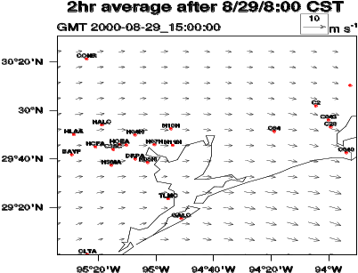 | 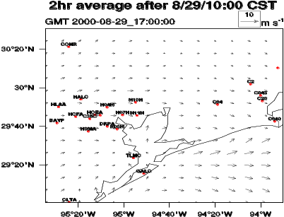
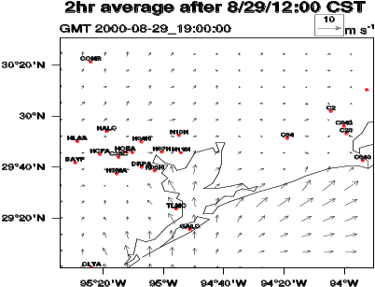 | 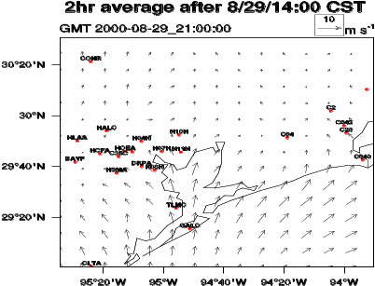
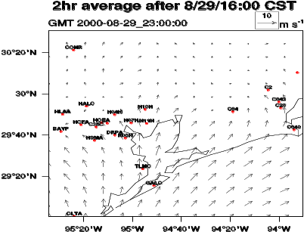 | 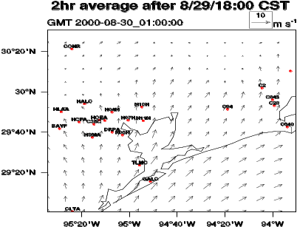
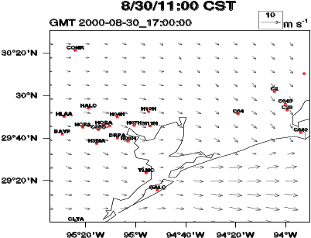 | 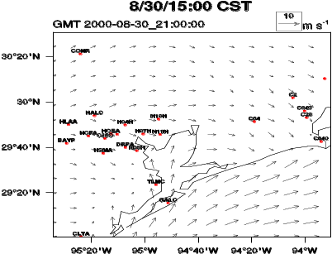
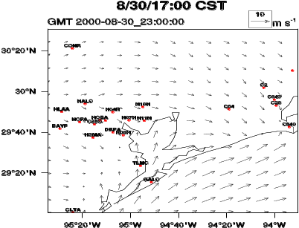 | 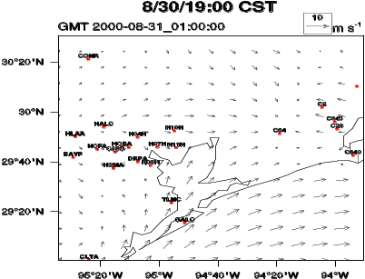
Figure 1. Predicted wind fields by WRF/Chem-MADRID on Aug. 29 and Aug. 30, 2000.
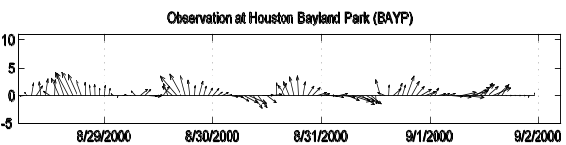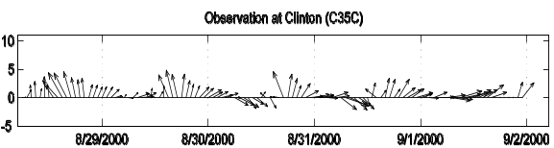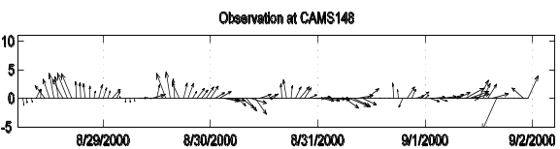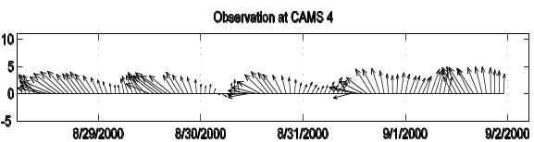  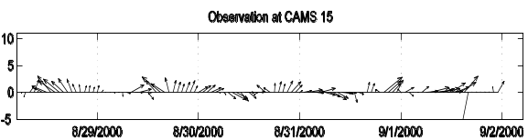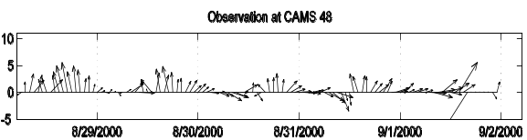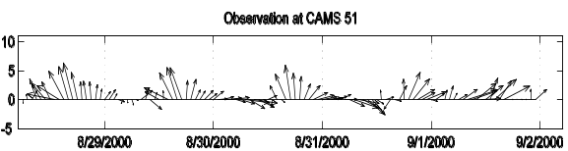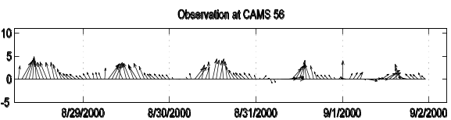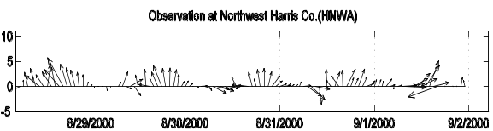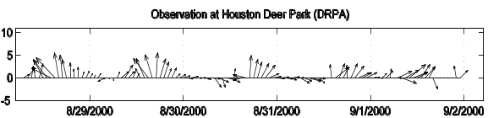 | 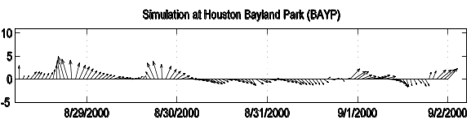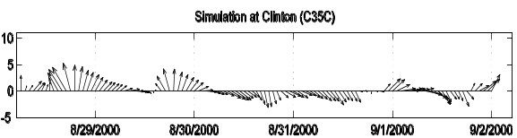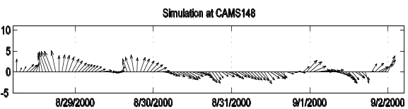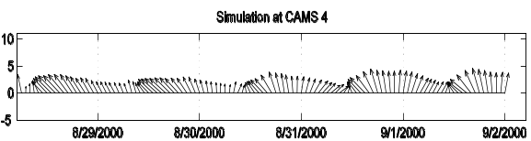  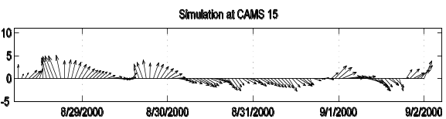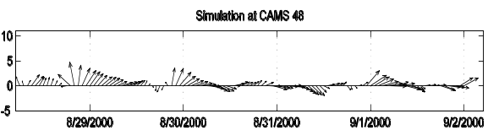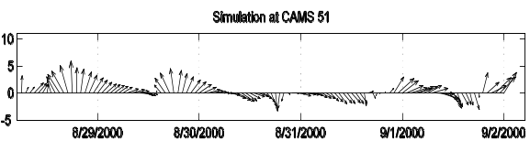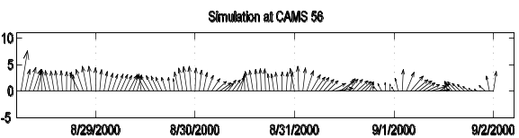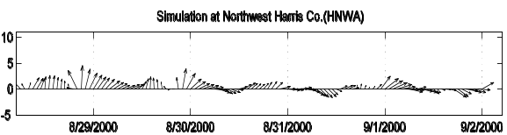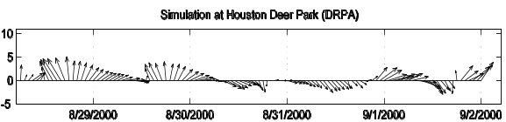
Figure 2. Observed and simulated temporal variations of wind vectors at 10 sites out of total 31 sites.
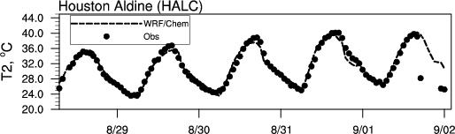  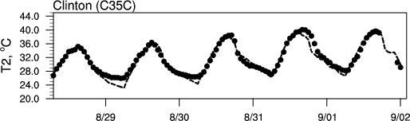  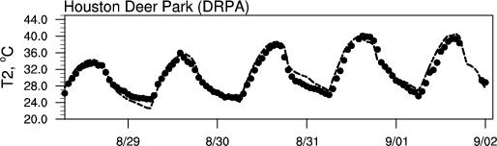  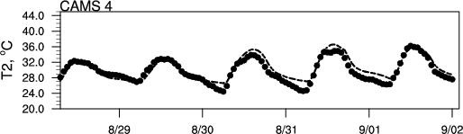  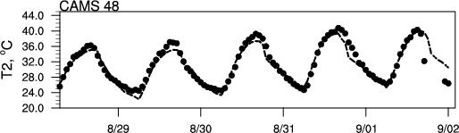  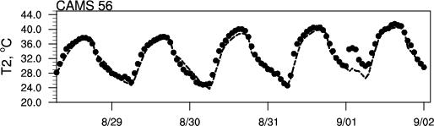  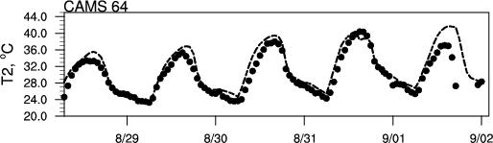  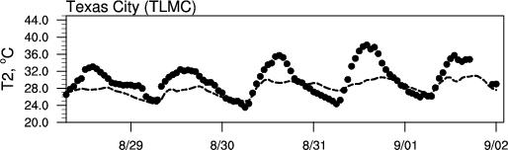 | 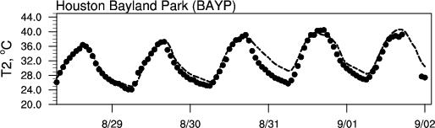  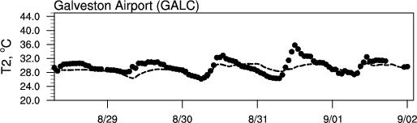  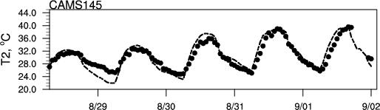  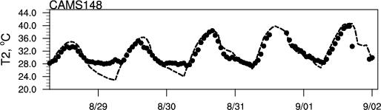  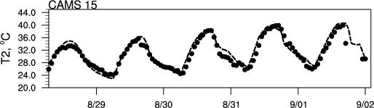  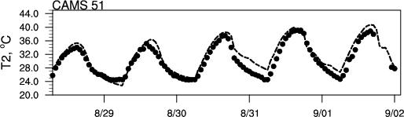  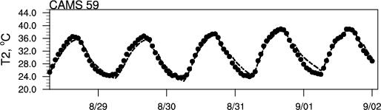  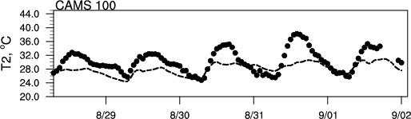
Figure 3. Observed and simulated temporal variations of temperatures at two meters (T2) at 16 sites out of total 32 sites.

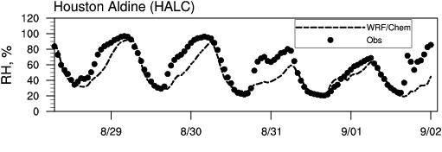  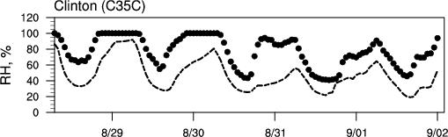  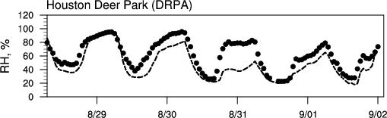 | 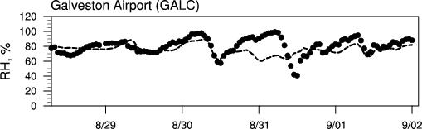  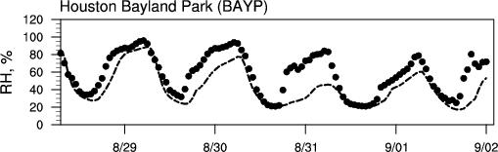  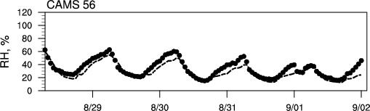
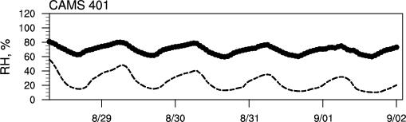
Figure 4. Observed and simulated temporal variations of relative humidity (RH) at two meters at 7 sites.
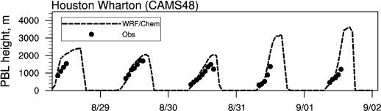  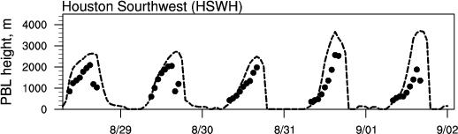 | 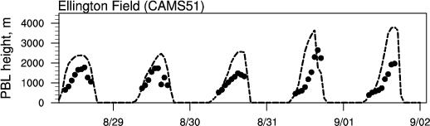  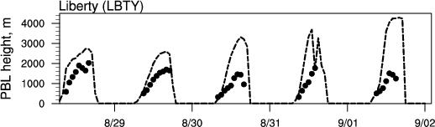
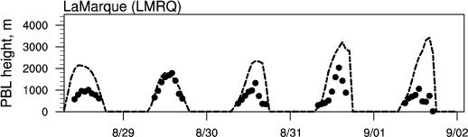
Figure 5. Observed and simulated temporal variations of PBL height at 5 sites.
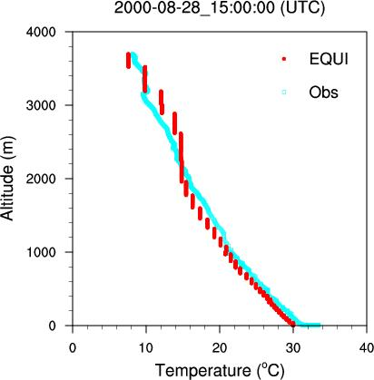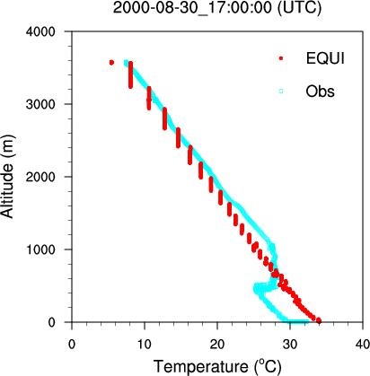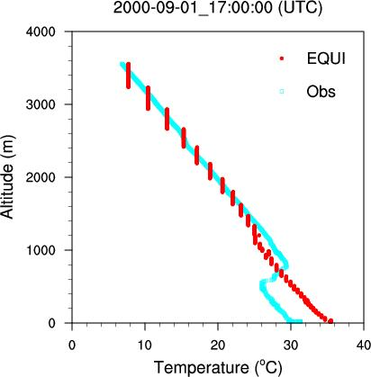 | 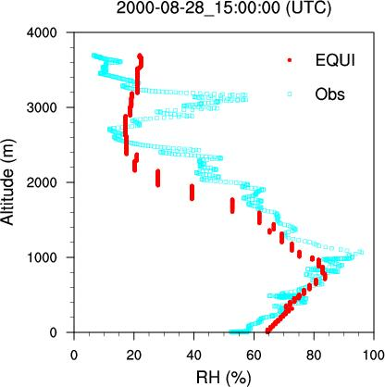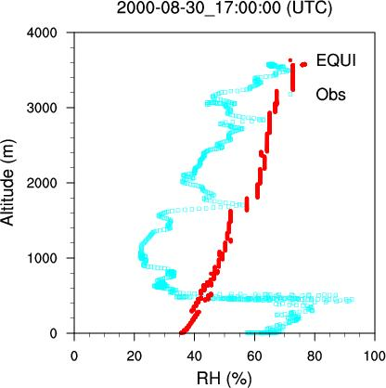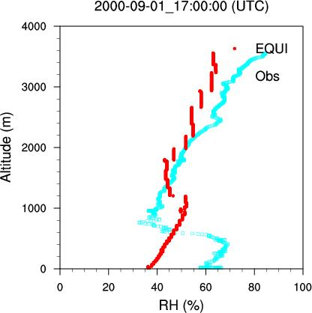 | 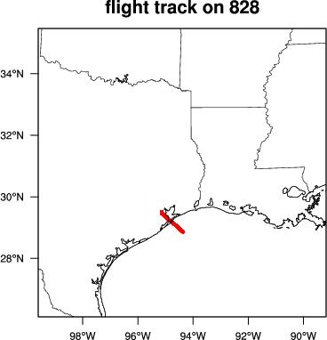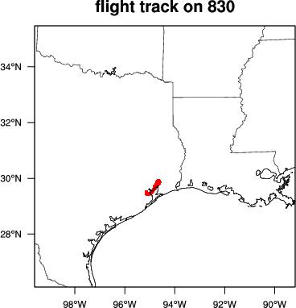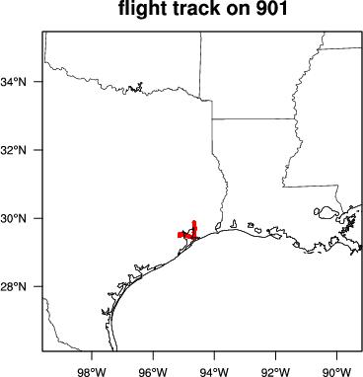
Figure 6. Comparison of simulated and observed vertical profiles of temperature and relative humidity (RH). The corresponding flight tracks of Electra aircraft are shown in the third column.
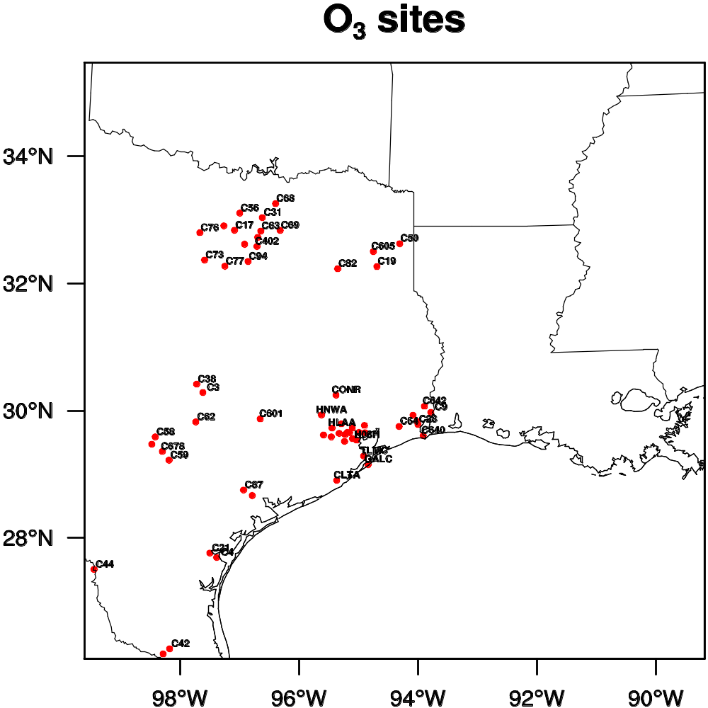
Figure 7. Locations of the TCEQ O₃ observational sites.
Replot with all sites for met and PM2.5 obs using different colors/symbols, see comments in YZ2. Please move this as Figure 1 and change text accordingly.

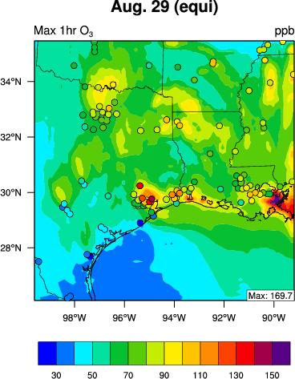 | 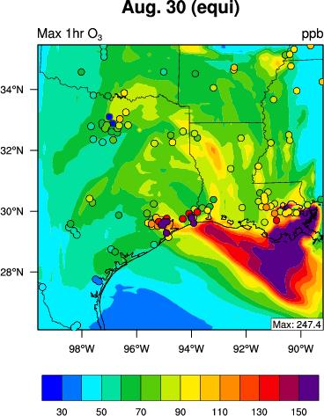
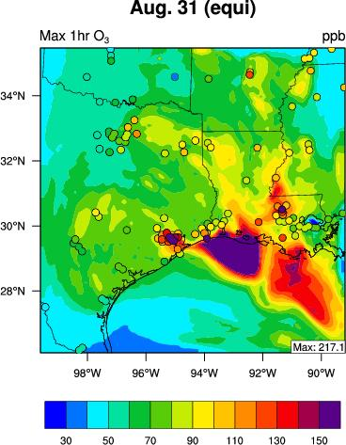 | 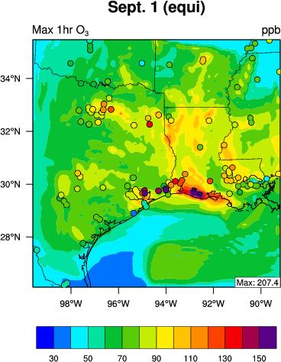
Figure 8. Overlay of observed and predicted max 1-h O₃ spatial distributions. The observed max 1-h O₃ values are indicated by the symbol “o”. The simulation results are based on WRF/Chem-MADRID (EQUI).
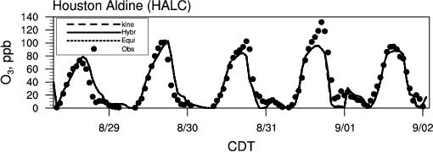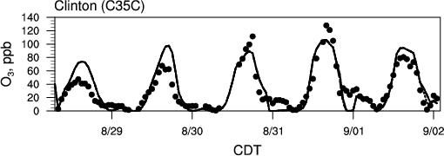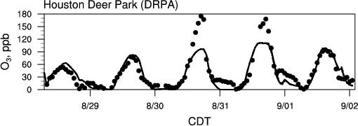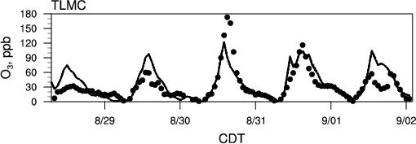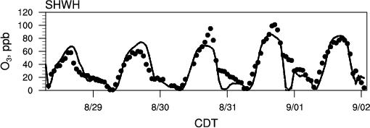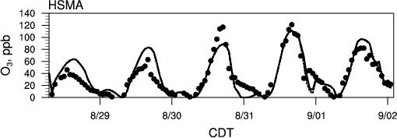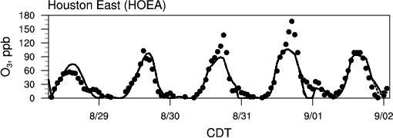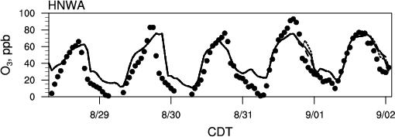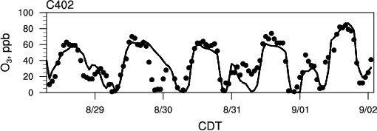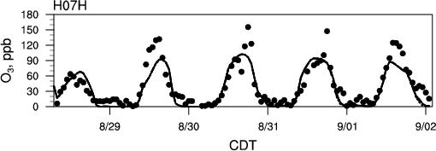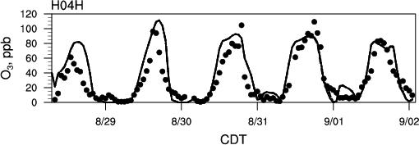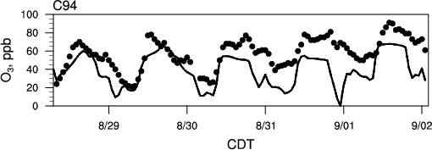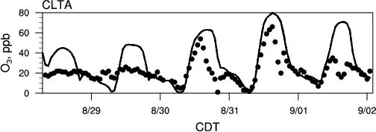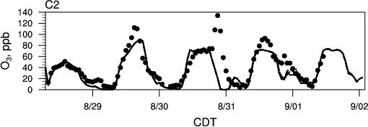 | 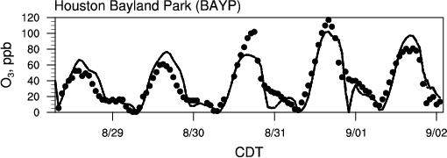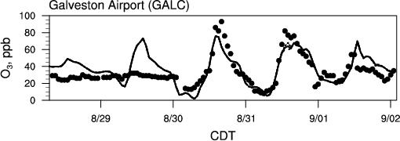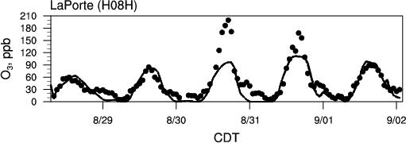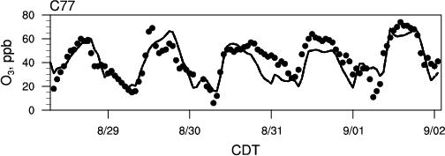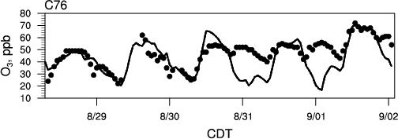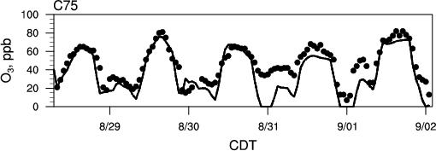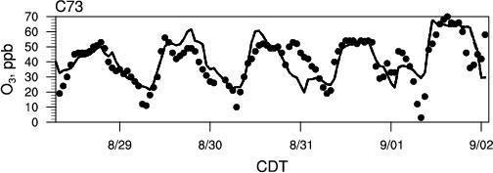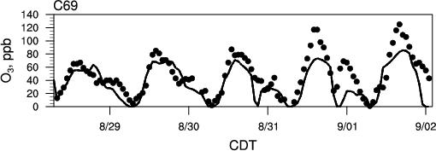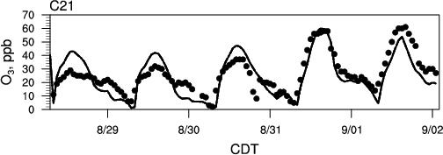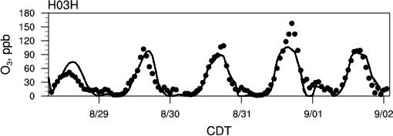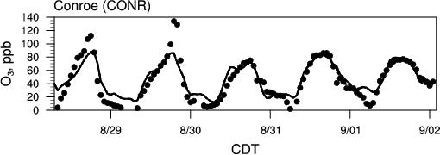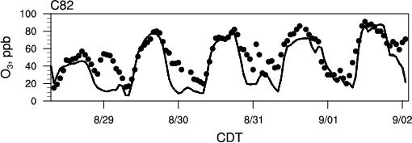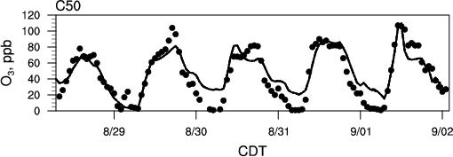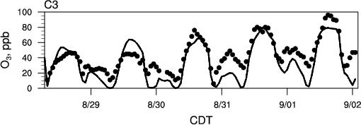 | 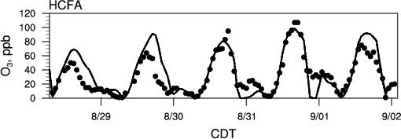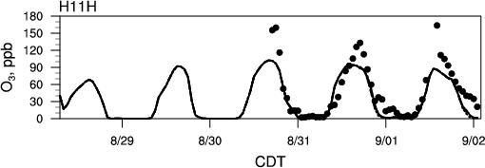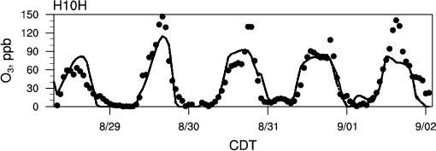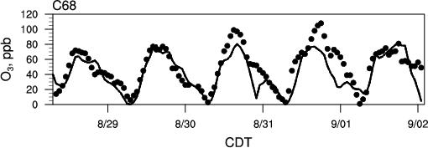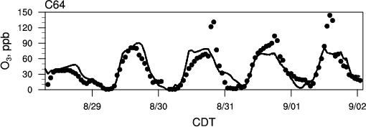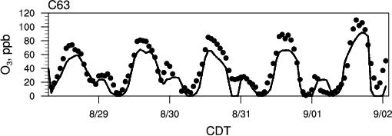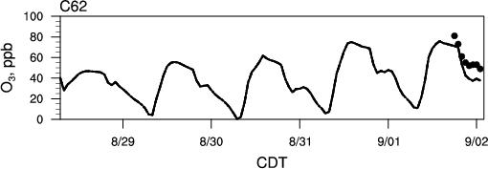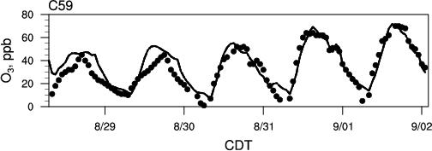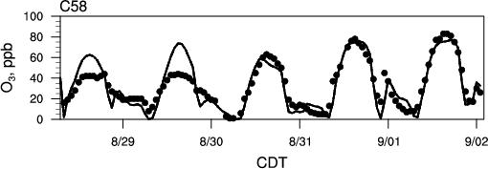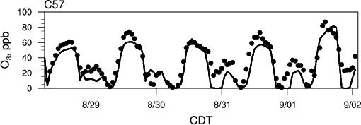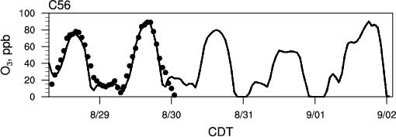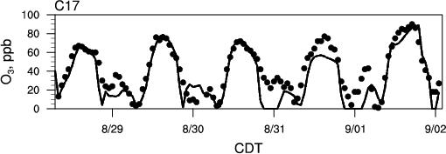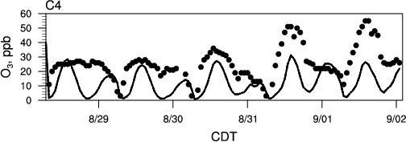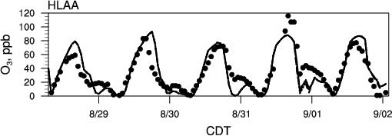
Figure 9. Observed and simulated temporal variations of O₃ mixing ratios at 42 out of total 60 observational sites in TX.
Please reduce to 10-16 sites, see YZ2 comments.
In figure 5, please reduce the font size of the subtitles, they are too close to the X label of the figures above them (see e.g., plot for CONR).
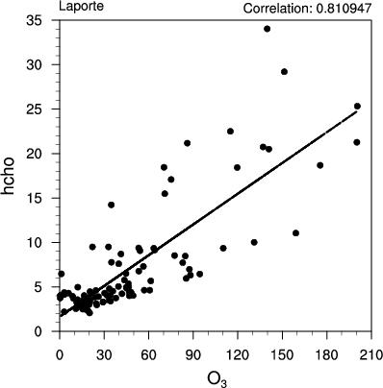 | 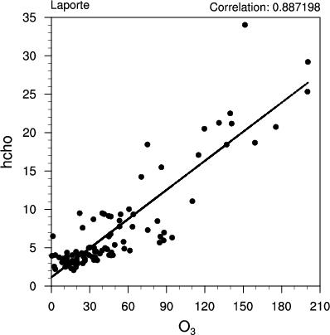
(a) HCHO correlate with O₃ at the same time | (b) HCHO correlate with O₃ 1-h later
Figure 10. Correlation at LaPorte, TX between (a) measured HCHO and O₃; (b) measured HCHO and O₃ 1-hr later.
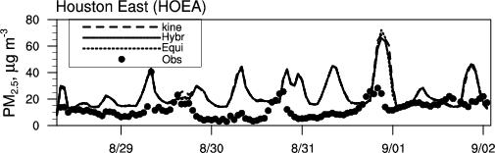  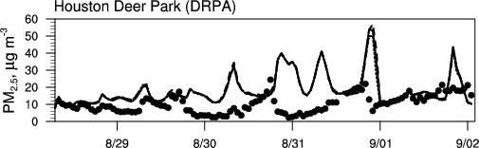  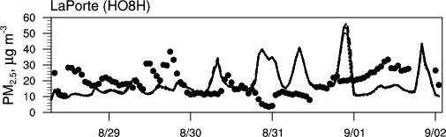  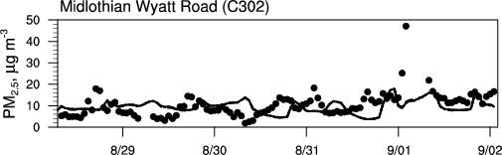  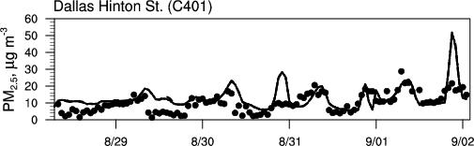  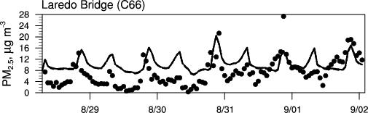  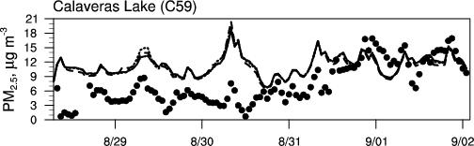  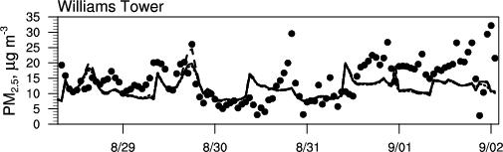 | 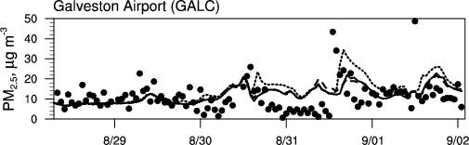  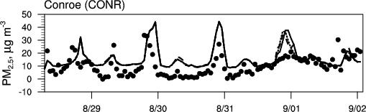  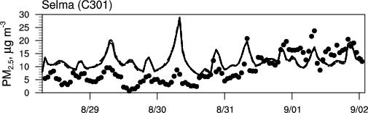  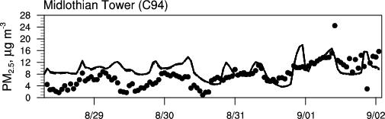  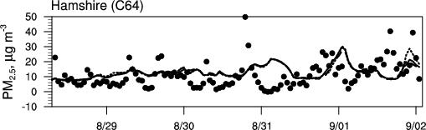  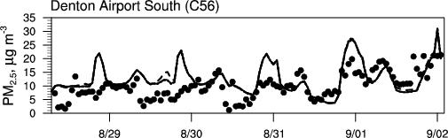  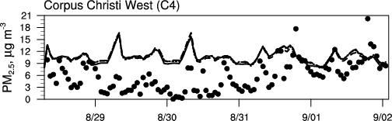
Figure 11. Observed and simulated temporal variations of PM_{2.5} concentration at 15 sites.

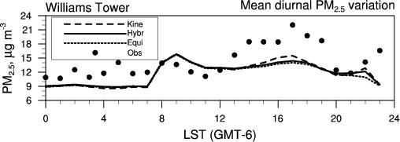  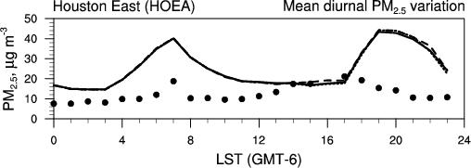  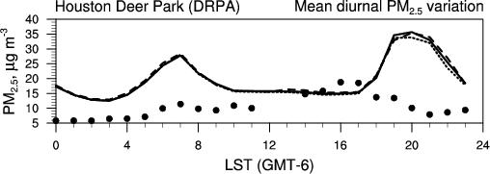  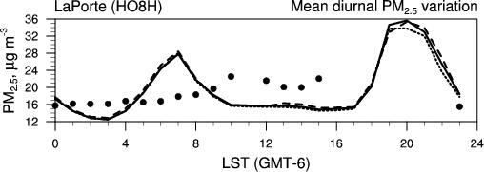  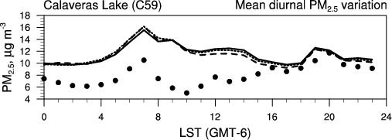  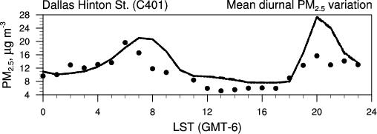  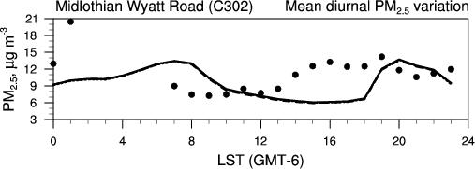  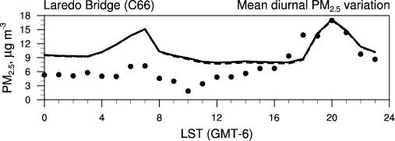 | 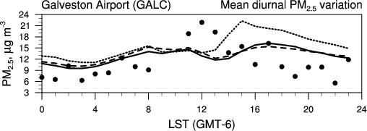  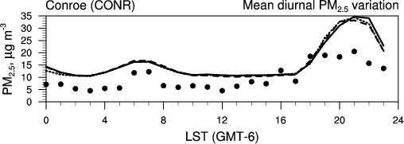  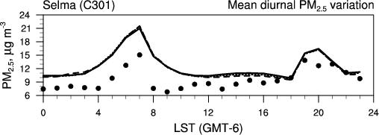  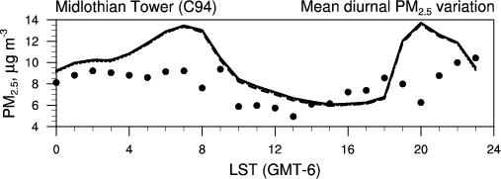  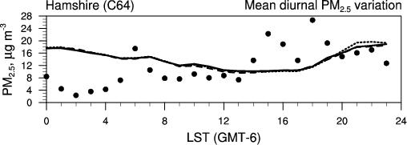  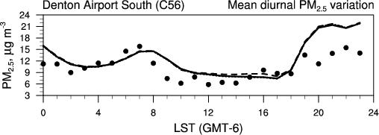  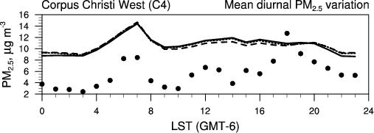
Figure 12. Mean diurnal pattern of PM_{2.5} mass concentrations at 15 observational sites.
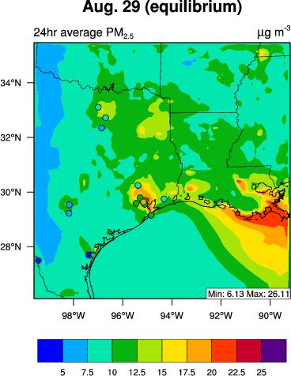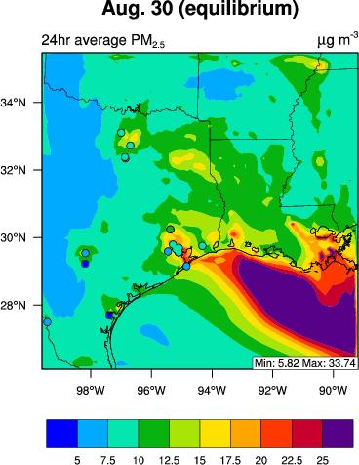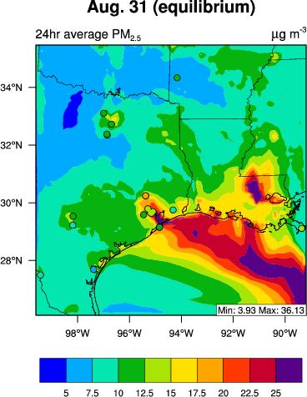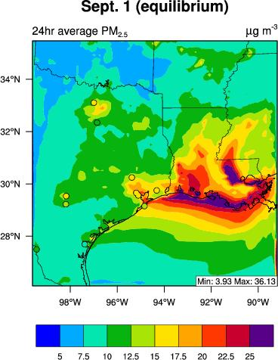 | 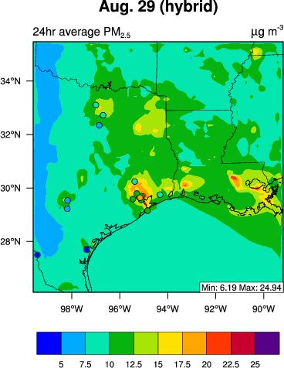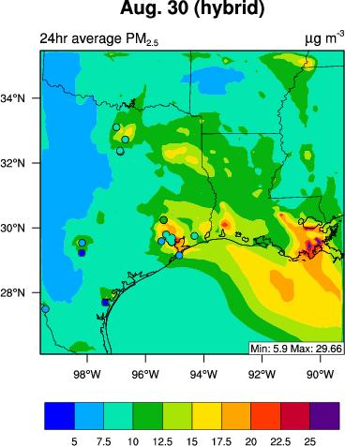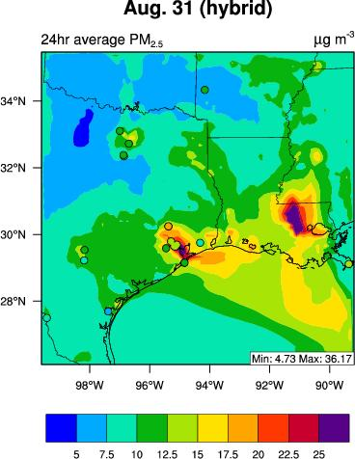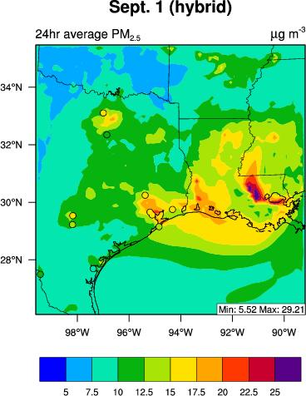 | 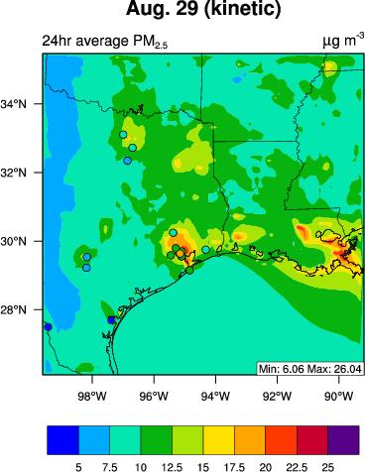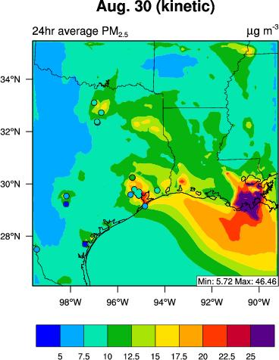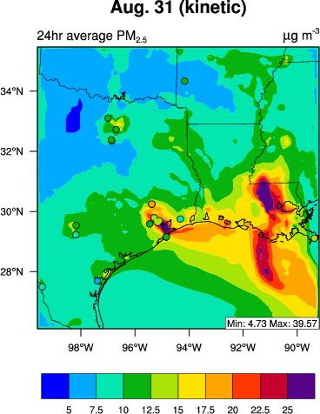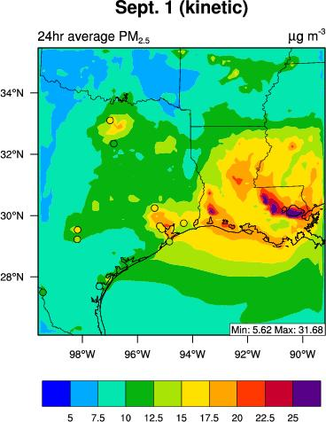
Figure 13. Overlay of observed and simulated daily average spatial distributions of PM_{2.5} mass concentrations. The measured daily average PM_{2.5} are indicated by the symbol “o”.
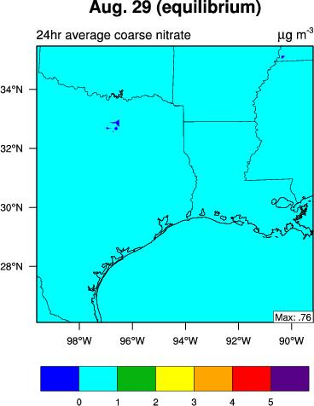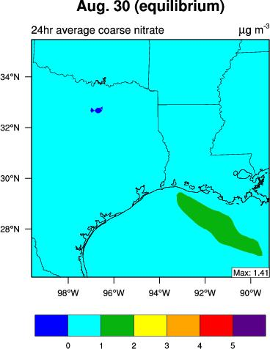  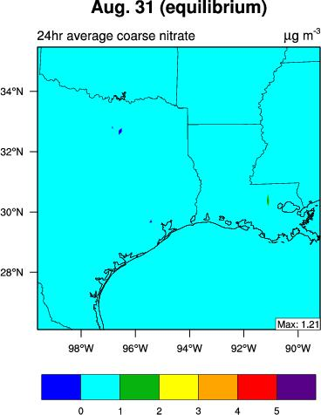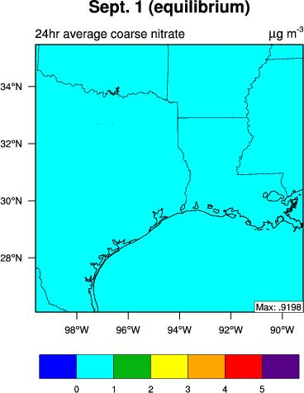 | 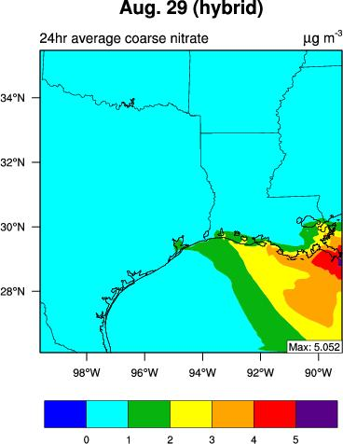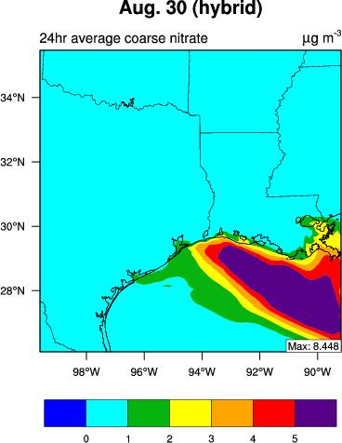  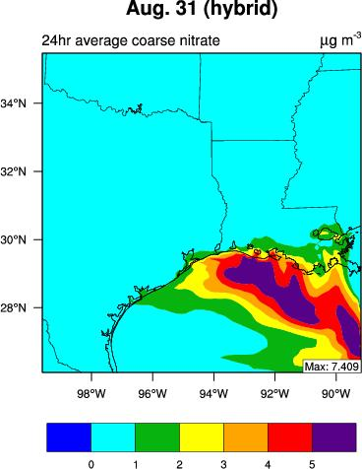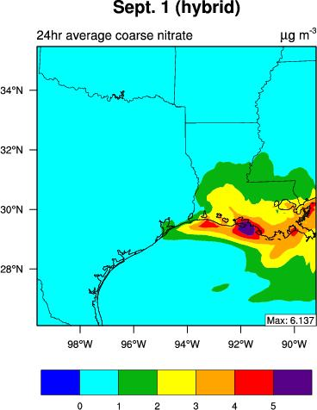 | 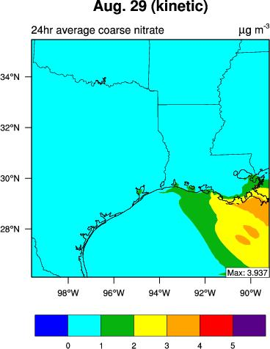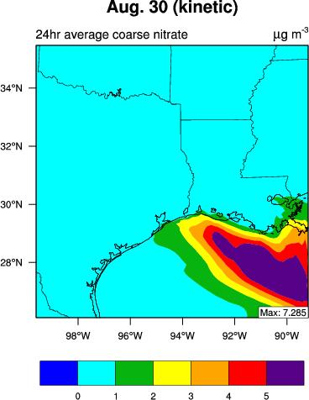  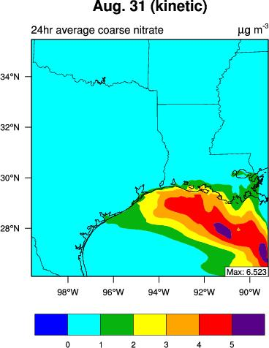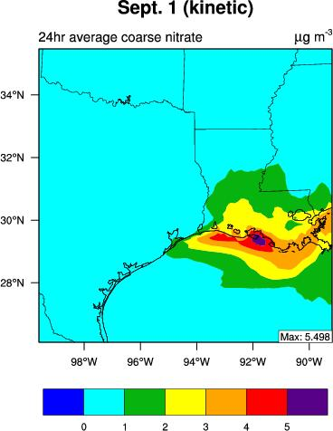 | 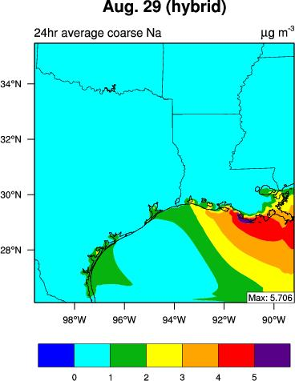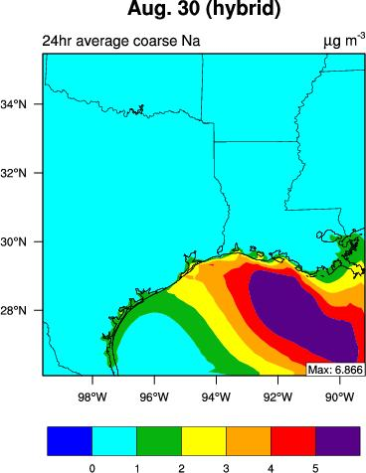  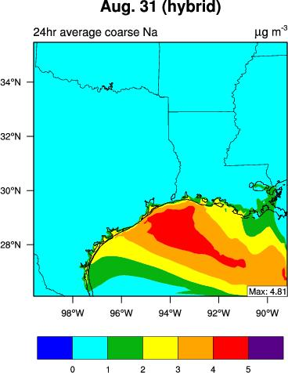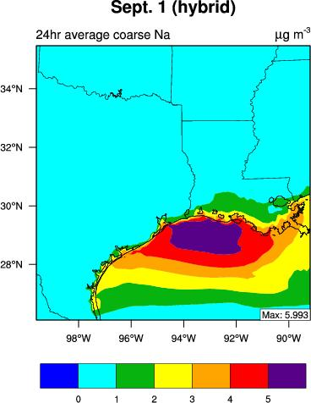
Figure 14. Daily average spatial distributions of simulated coarse nitrate concentrations from WRF/Chem-MADRID (EQUI), (HYBR), and (KENI) and sodium mass concentrations from WRF/Chem-MADRID ( (KENI) (please replace column 3 by plots from KENI run)..
Equilibrium | Hybrid | Kinetic
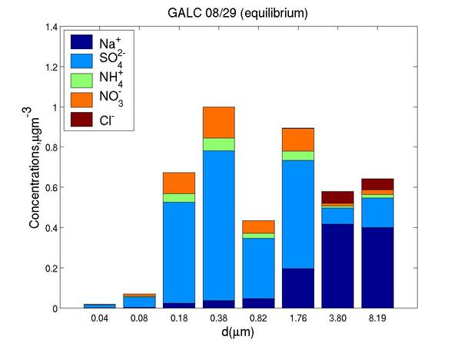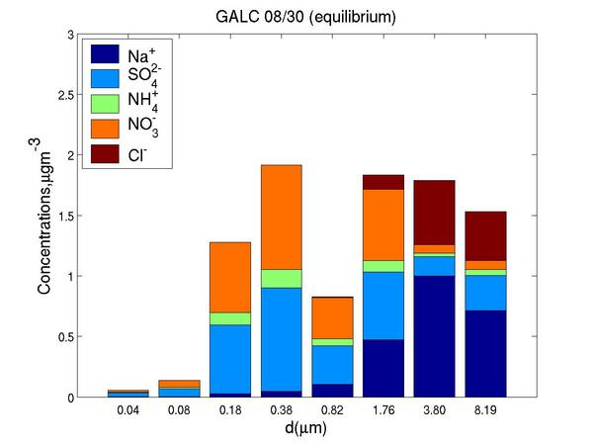  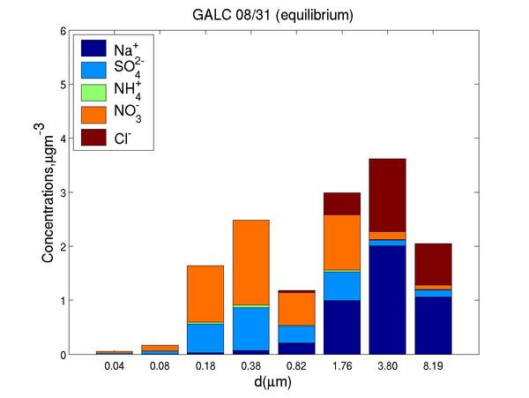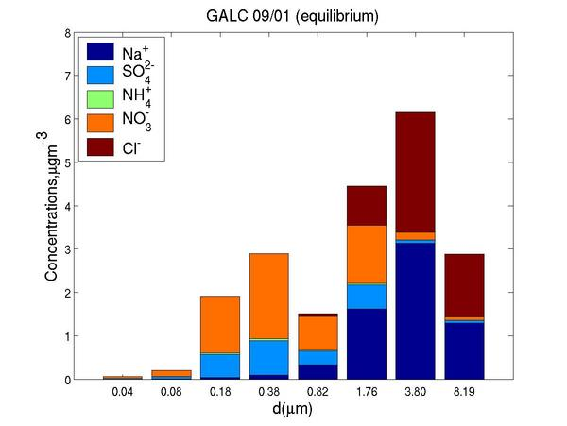 | 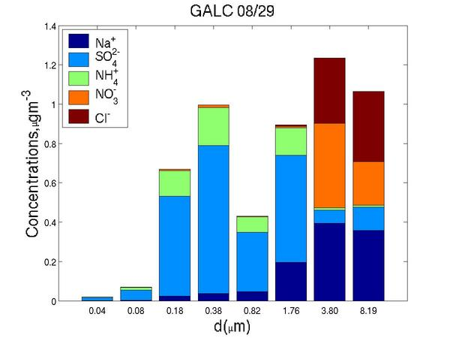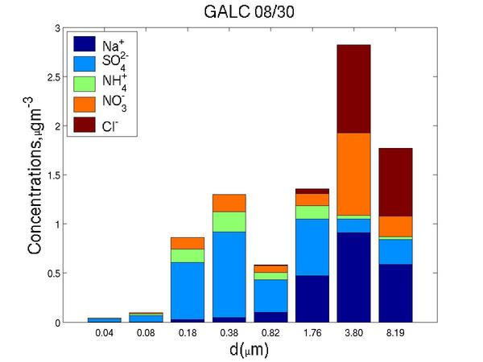  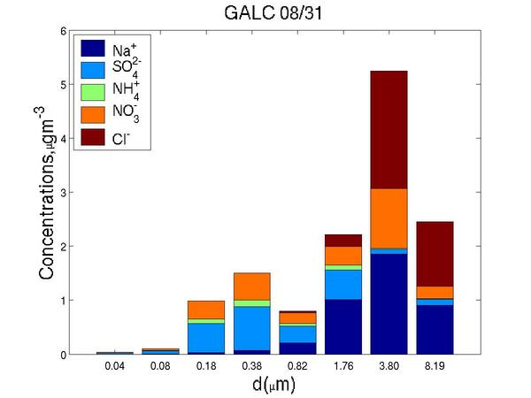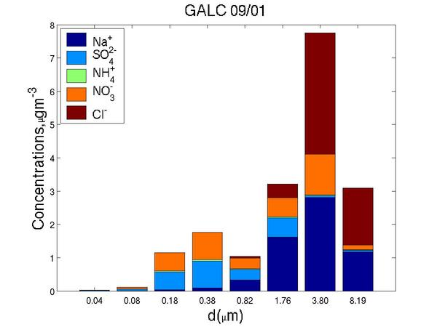 | 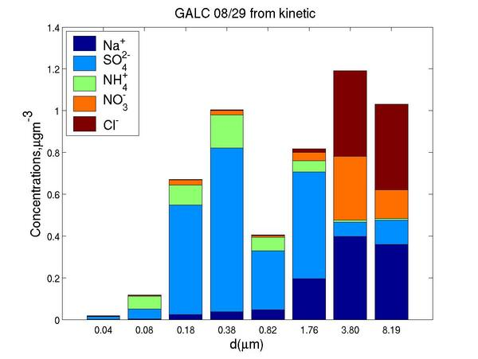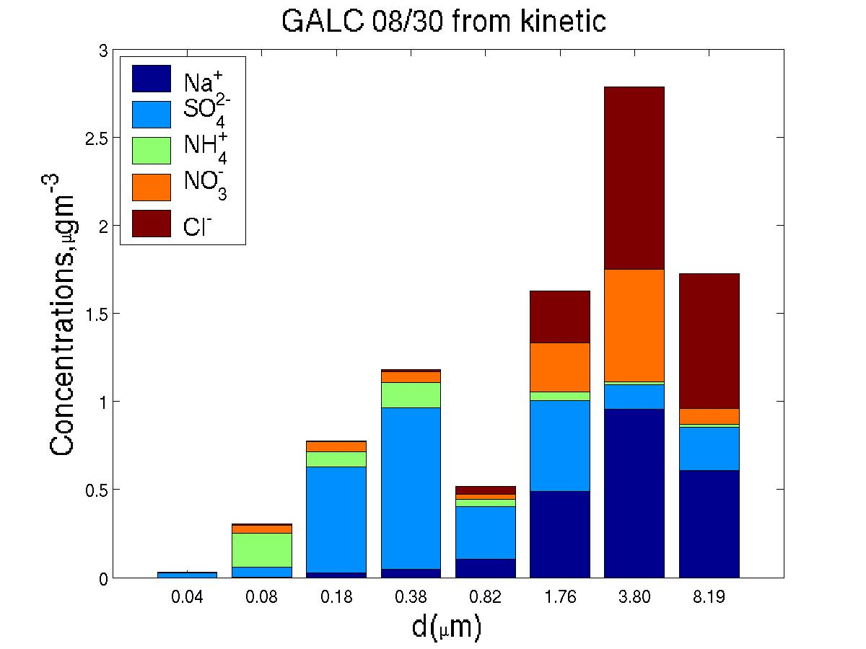  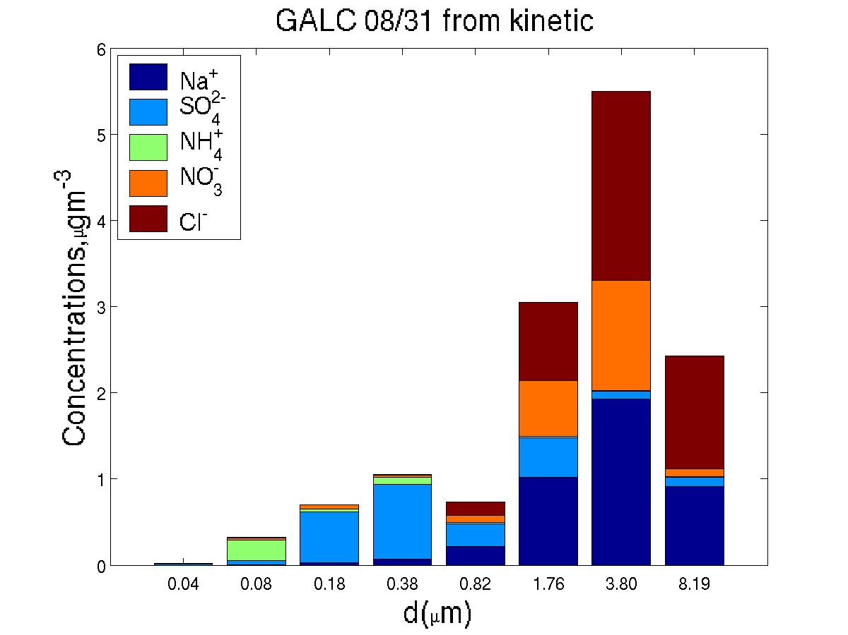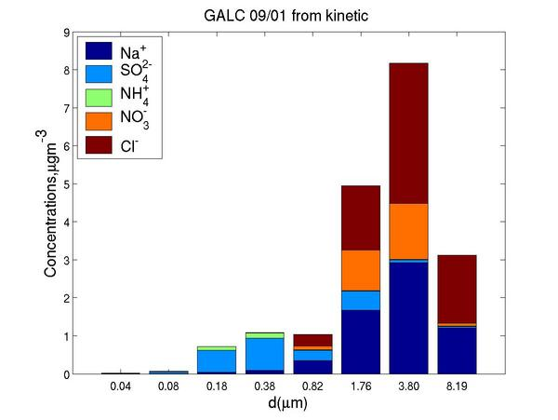
Figure 15. Predicted size-resolved PMcomposition distributions at GALC from WRF/Chem-MADRID with different mass transfer approaches.

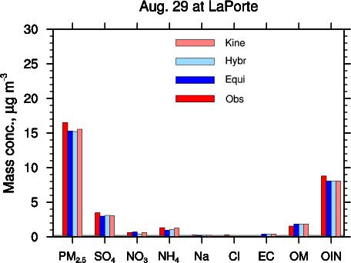 | 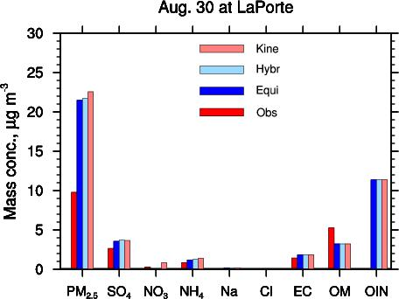
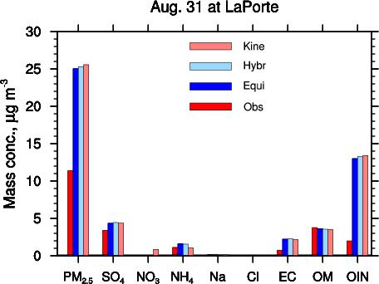 | 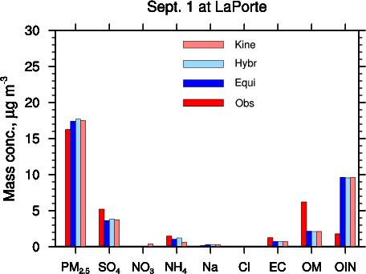
Figure 16. The mass concentrations of daily average PM_{2.5} and its component at LaPorte, TX.

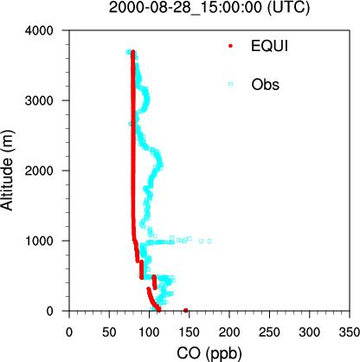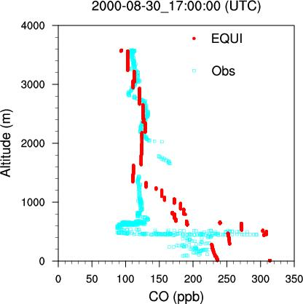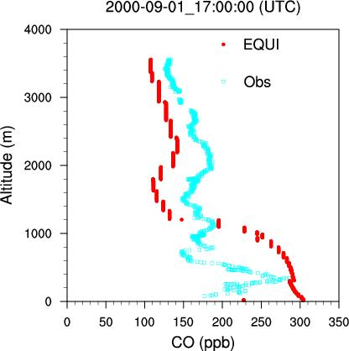 | 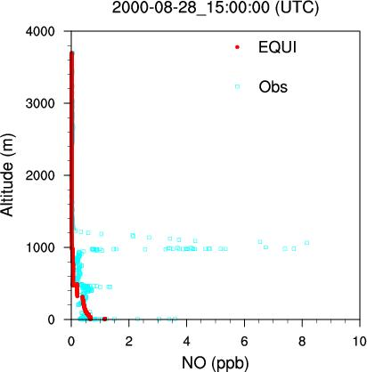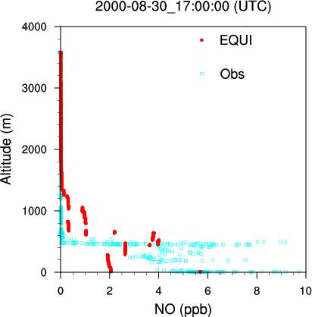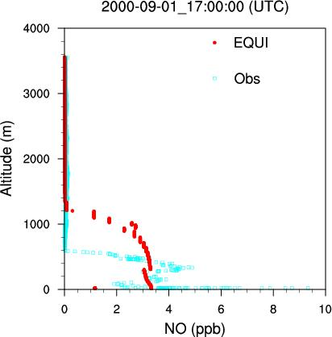 | 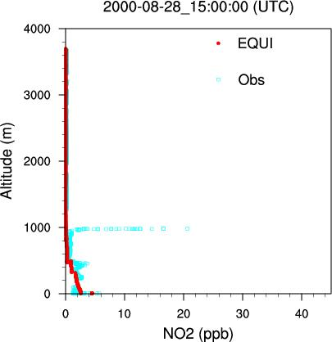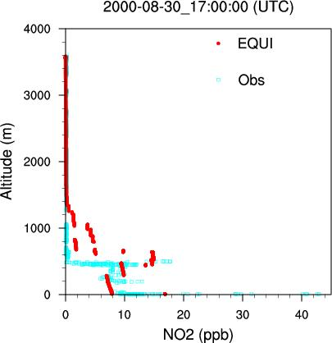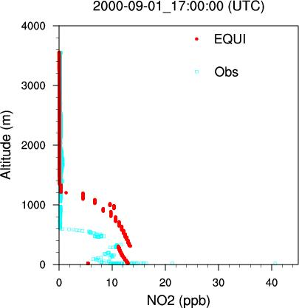 | 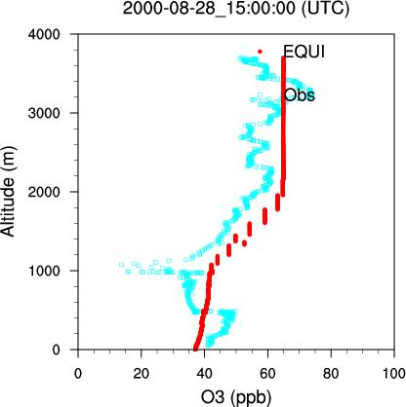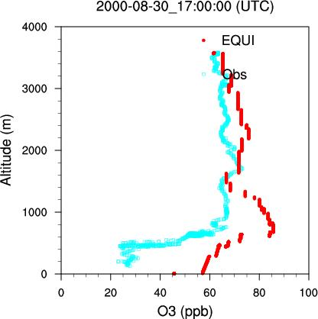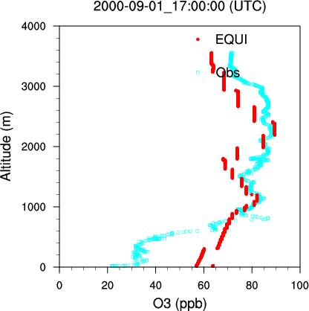
Figure 17. Comparison of simulated and observed vertical profiles of chemical species (CO, NO, NO₂, and O₃).
Please indicate if this is from EQUI run

TOMS TOR | Simulated TOR
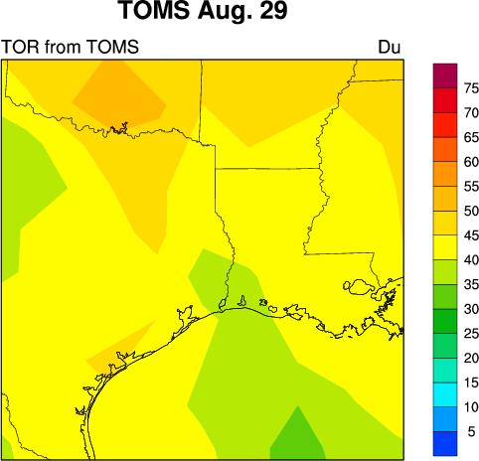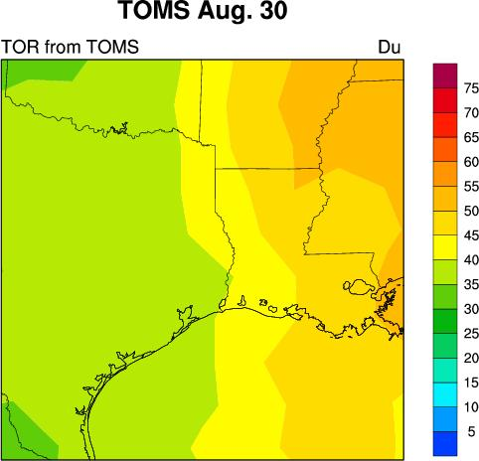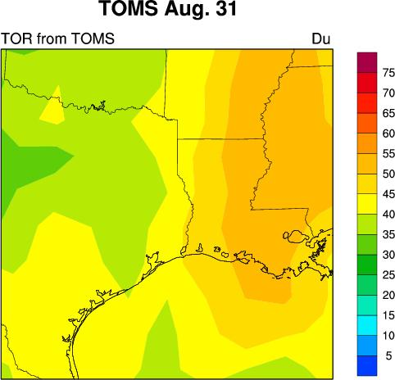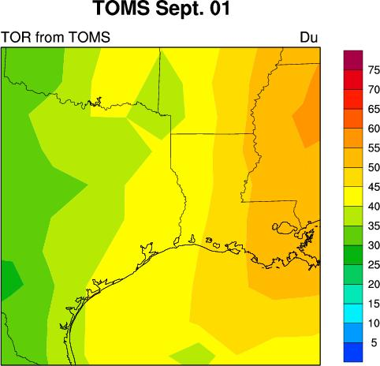 | 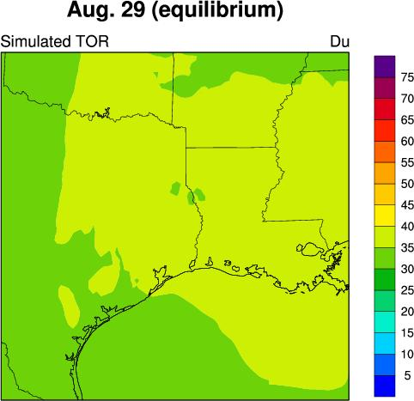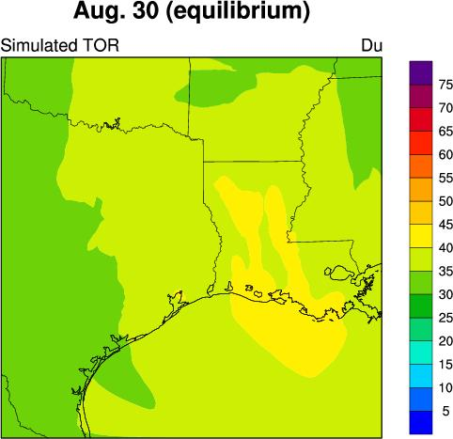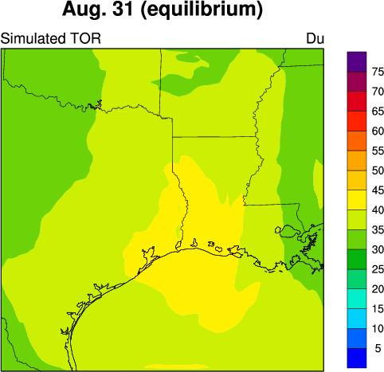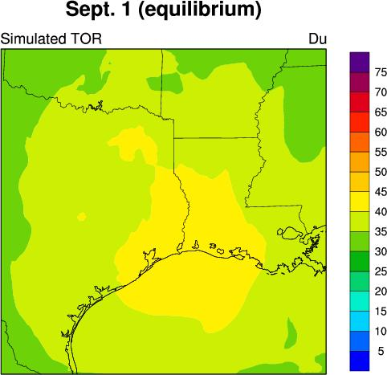
Figure 18. Comparison between simulated Tropospheric Ozone Residue (TOR) and observed TOR from TOMS/SBUV.
Please indicate if this is from EQUI run

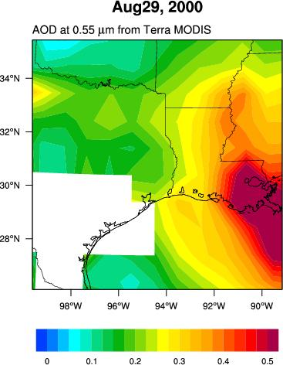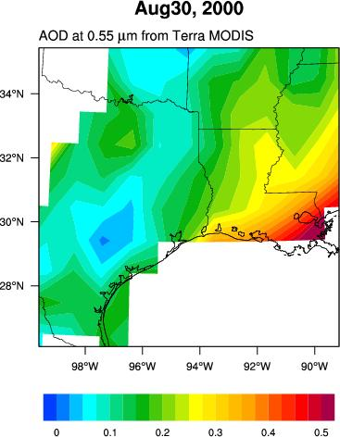  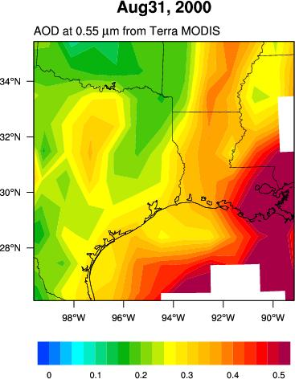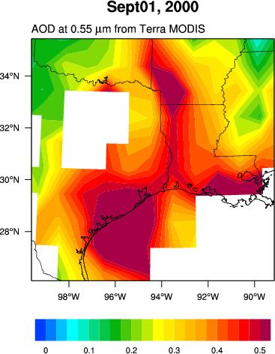 | 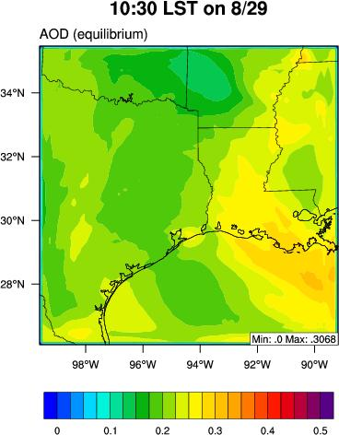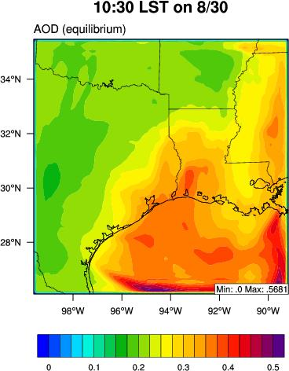  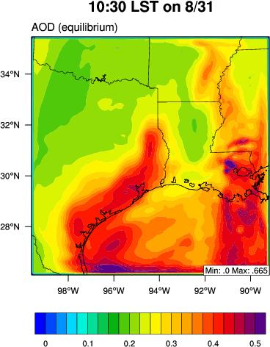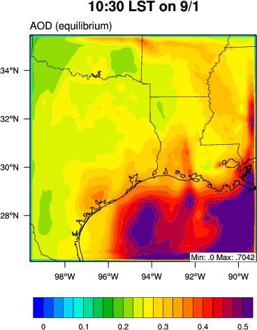 | 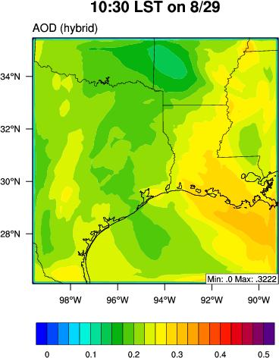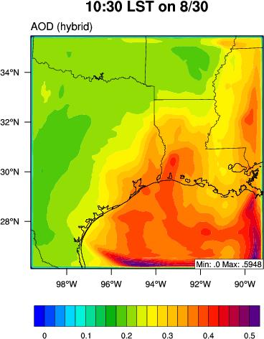  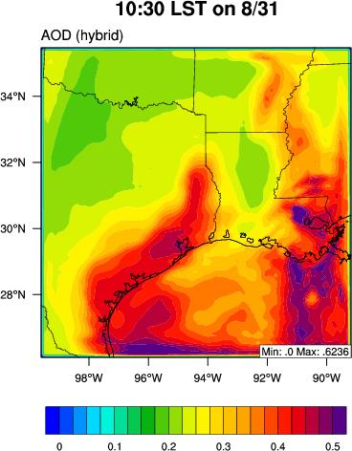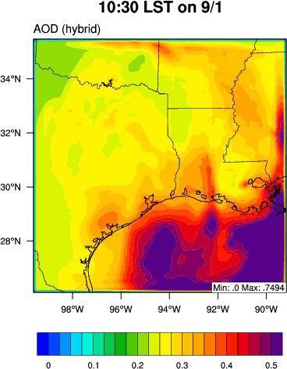 | 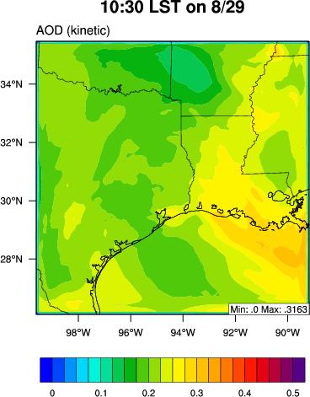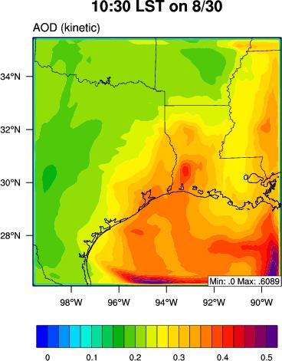  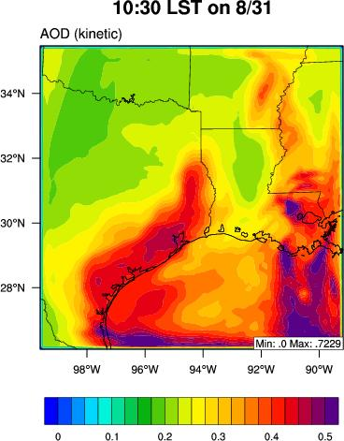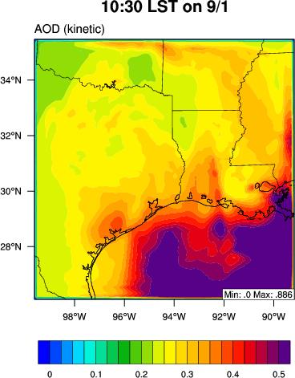
Figure 19. MODIS-derived AOD and simulated total column AOD from WRF/Chem-MADRID..
The blank areas in the MODIS AOD plots contain no MODIS data. Please indicate if this is from EQUI run
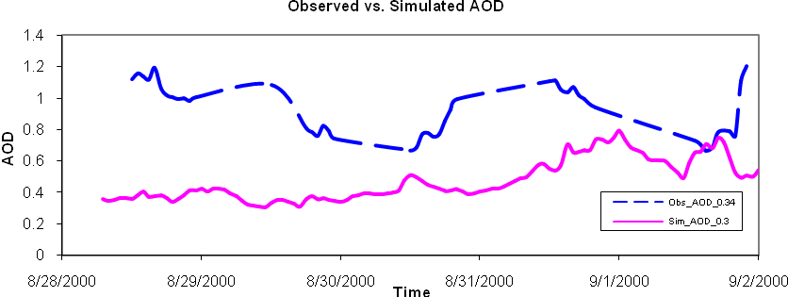
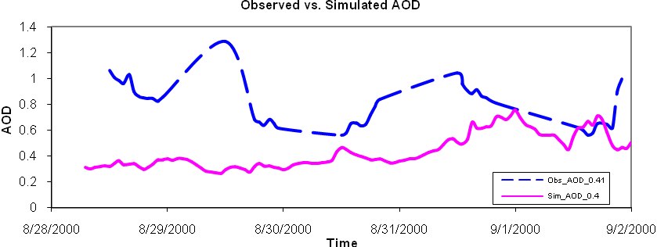
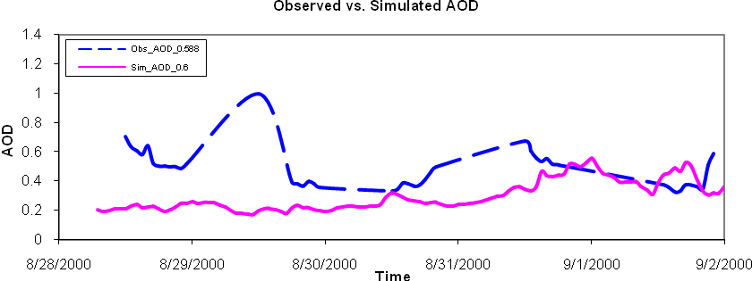
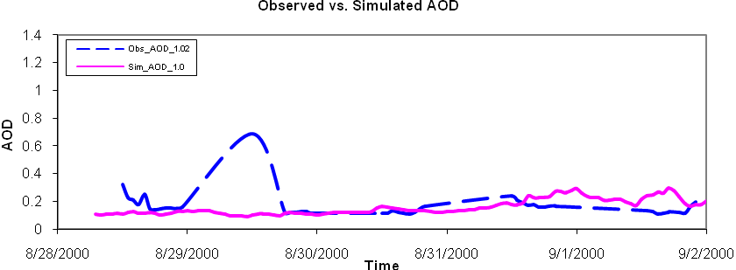
Figure 20. Comparison between simulated and AERONET observed total column AOD at Stennis, Mississippi (N 30 22’ 04”, W 89 37’ 01”) at four wavelength (i.e., 0.3, 0.4, 0.6, 1.0 µm).
Please indicate if this is from EQUI run
Absolute difference | Percent difference
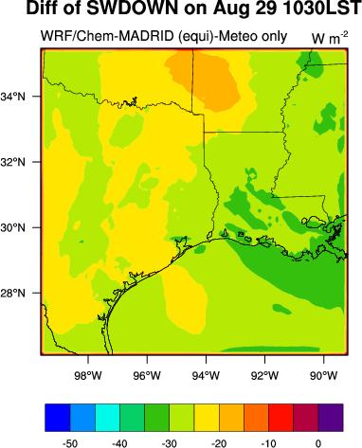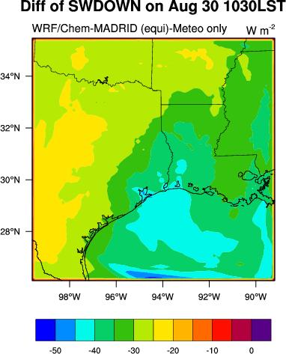  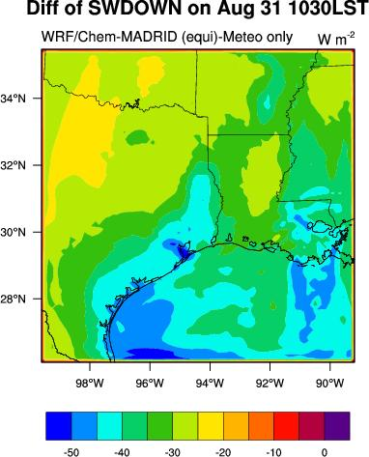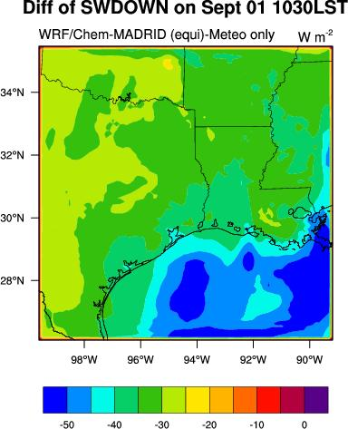 | 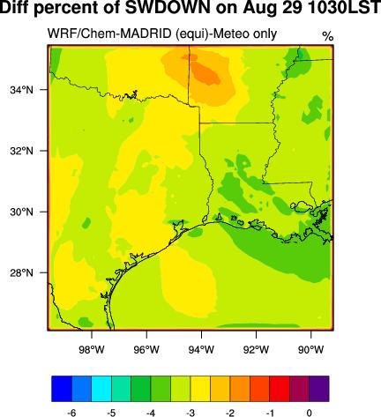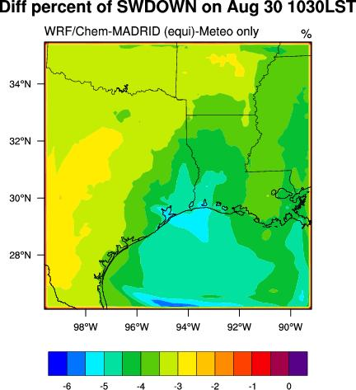  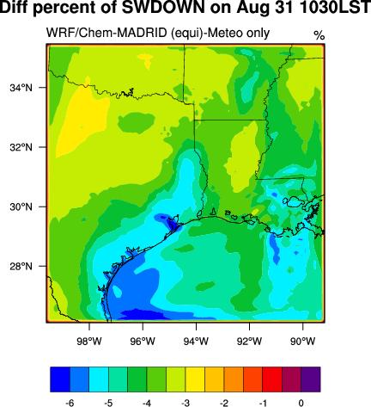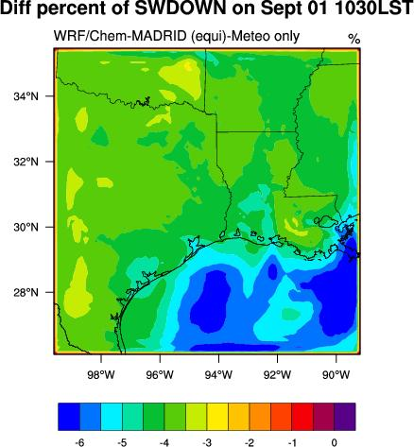
Figure 21. Absolute (left panel) and percentage (right panel) differences of surface downward shortwave radiations simulated by WRF/Chem with and without aerosols. (need to rerun and replot)
Please use KINE run results
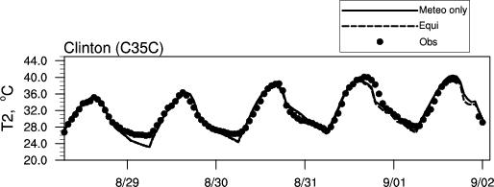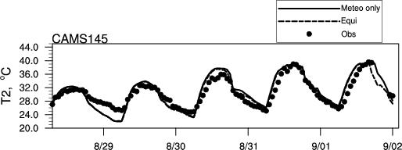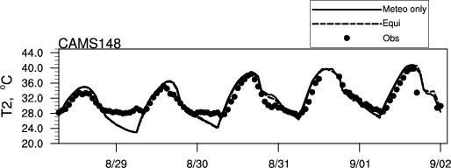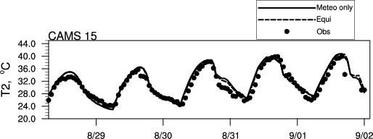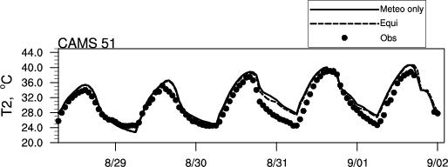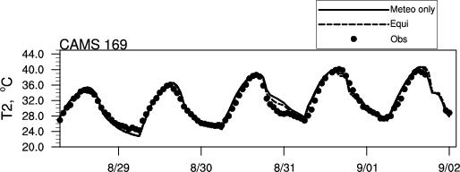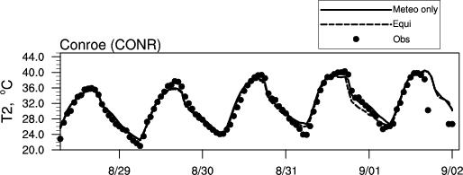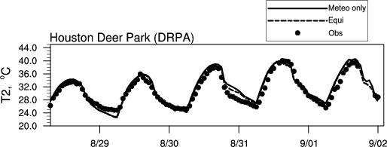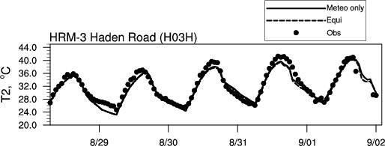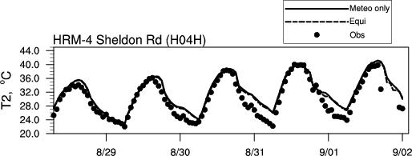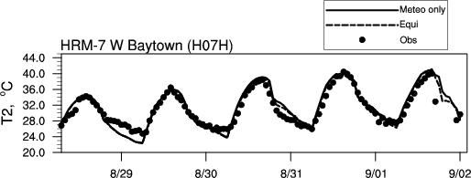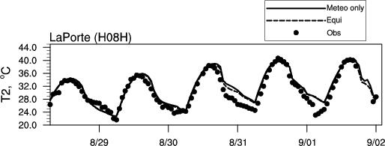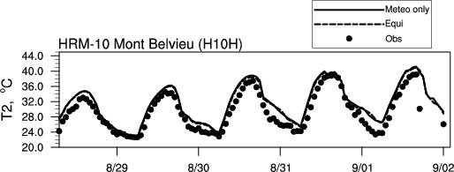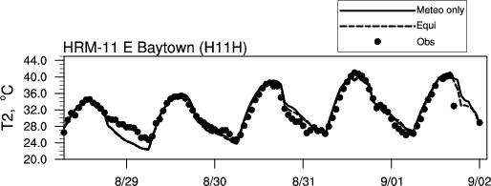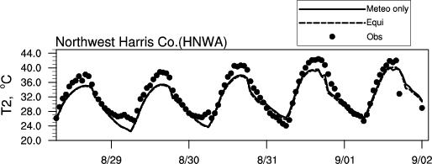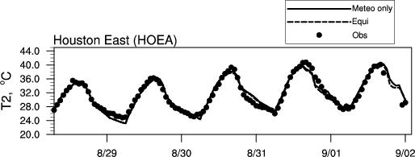
Figure 22. Simulated T2 by WRF/Chem-MADRID with and without gases and aerosols at 16 surface observational sites in TX. Please replace this figure by vertical profiles of PM2.5 from WRF/Chem-MADRID and absolute difference plots for vertical profiles of T and QV between at WRF/Chem-MADRID (KENI) and WRF only at four sites: HOEA, DPRA, LaPorte, GALC, also update your text discussions.

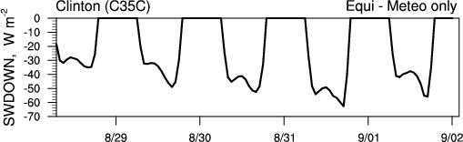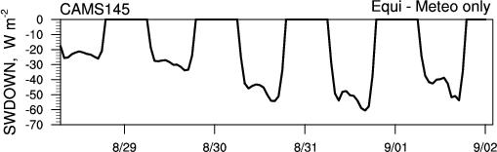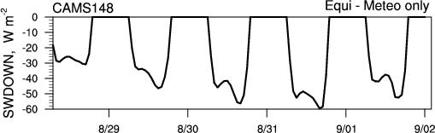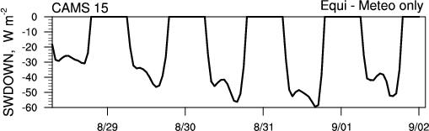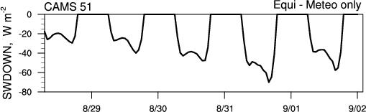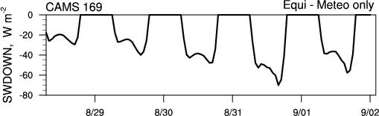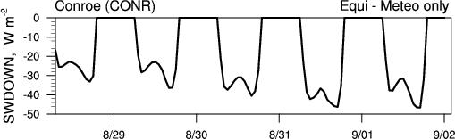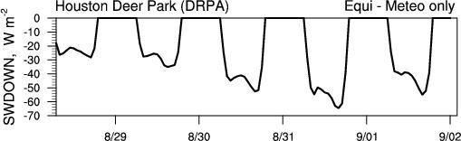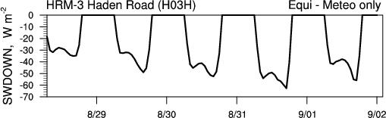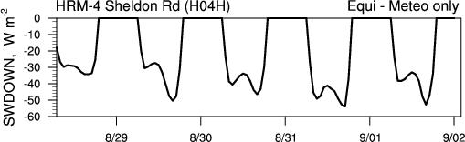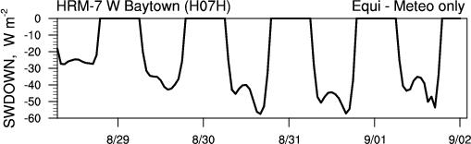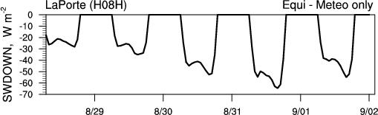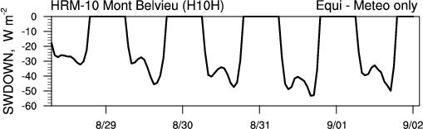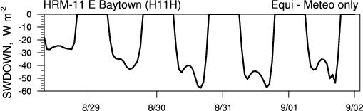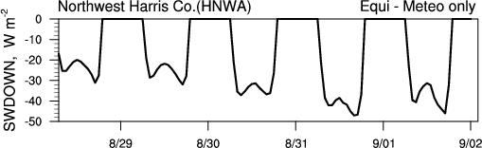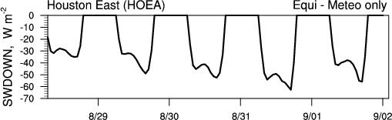
Figure 23. Aerosol radiation forcing simulated by WRF/Chem-MADRID at 16 surface observational sites in TX. Please use KINE run results and indicate it here.

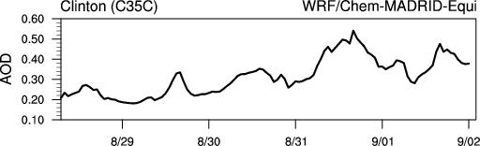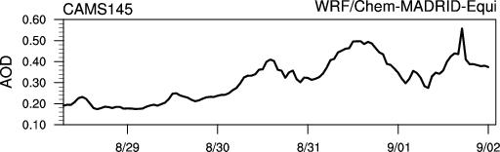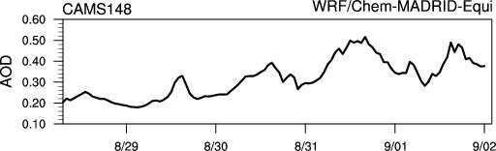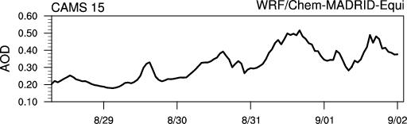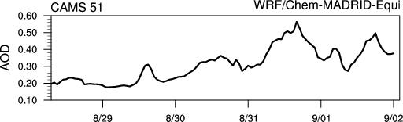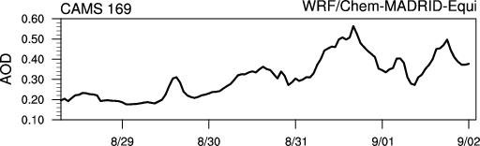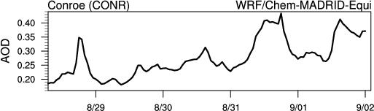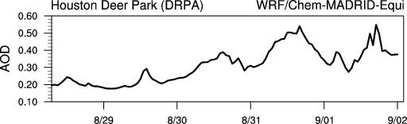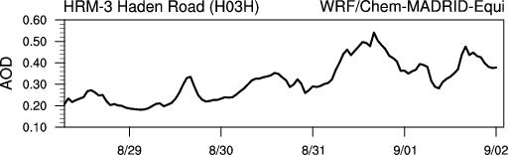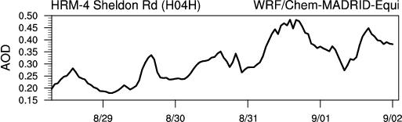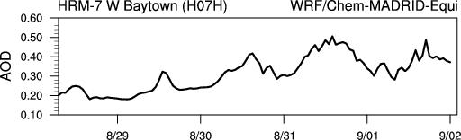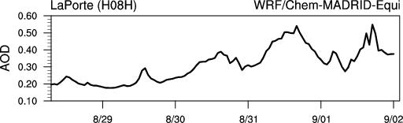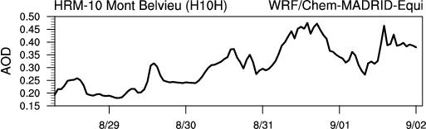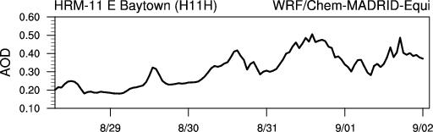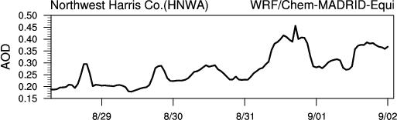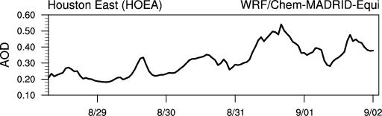
Figure 24. Observed and simulated AOD simulated by WRF/Chem-MADRID at 16 surface observational sites in TX. (please extract obs MODIS AOD and add them into the figures for comparison (you will have 10 data points from MODIS AOD for each plot, right?).

* Corresponding author: Yang Zhang, Department of Marine, Earth and Atmospheric Sciences, Campus Box 8208, NCSU, Raleigh, NC 27606, phone (919) 515-9688, e-mail: yang_zhang@ncsu.edu

